Curry Rivel  Church of England  Primary School | 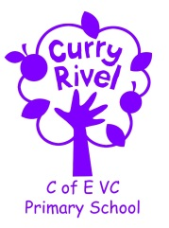  ‘Healthy Trees Bearing Good Fruit’ | Discovery Class  Autumn Newsletter  September 2024
Dear Parents/Carers,

Welcome back to the start of another school year; I hope you have enjoyed a brilliant, relaxing break full of well-earned downtime and plenty of memories with family and friends. It is exciting to be back to school at the start of a new academic year, and I am looking forward to working with your children as they take the next step in their education.

I hope that this newsletter gives you a flavour of what you can expect from the term ahead. Communication is so important, and although the beginning/end of the day does not allow for long conversations, you can always contact me via the school office. We will also have parents’ evening later in the term.

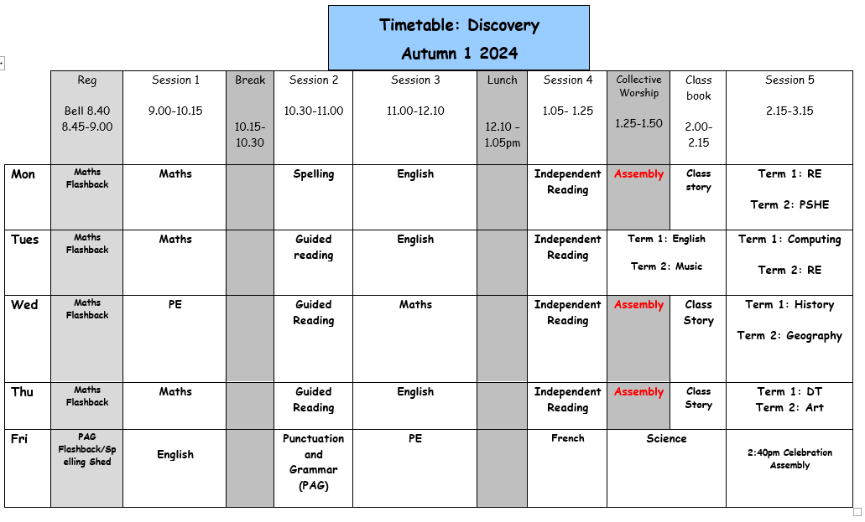
I feel it is important that you have an understanding of what the school day looks like. Please see the timetable below, which illustrates a typical week in Discovery Class this term- this can be used to help you have conversations about what your child has been learning in school each day.

I look forward to working alongside you to help your child develop and grow their confidence, self-esteem and attitude as we enter their journey into Year 4. I really hope your child enjoys their time in Discovery Class.

Mr Bridgeman








SUPPORT TEAM
It is always good to know which other adults are supporting our class, so here is the support team:

Miss Laurence, Mrs Klimpke & Mrs Ingham are 1:1 Teaching Assistants in our class
Mrs Monk is the school SENDCo
Mrs Langford is the school ELSA (Emotional Literacy Support Assistant) across the school.
Mrs Shaw will be teaching RE to the class during teacher planning time on Tuesday afternoons. After half-term, Mrs Langford will take over with PSHE.

Mrs Monk
Mrs Langford
Mrs Ingham
Mrs Klimpke
Miss Laurence Mrs Shaw
English | - Diaries based on ‘The Matchbox Diary’ by Paul Fleischman  - Letters based on ‘Granny Came Here on the Empire Windrush’ by Patrice Lawrence  - Guided Reading skills based on ‘How Does a Lighthouse Work?’ by Roman Belyaev |  | Science | Animals Including Humans
Maths | Addition & Subtraction, Numbers to 10,000, Perimeter, Times Tables |  | Computing | The Internet – Connections & Networks
PE | Gymnastics, Hockey, Netball, Outdoor Adventurous Activities |  | Design Technology | Electronic Devices
Music  Art | Body and tuned percussion (Theme: rainforests)  Drawing: Power prints |  | Personal Social Health Economic Education (PSHE) | Online Safety
RE | Are all religions equal? |  | History | World War II – evacuees from London to Somerset
French | All About Me, Games & Songs |  | Geography | Beyond the magic kingdom: What is the sunshine state really like?
Please see the Knowledge Organisers for Science, History and DT (sent out separately) and use to discuss what your child is learning in school; you can use a Knowledge Organiser in different ways: Read through it together; discuss tricky vocabulary; quiz your child on the knowledge they have acquired; play true and false games with the facts.

Our Ambitious Curriculum at Curry Rivel Church of England Primary School

We aim for all our pupils to be ‘Caring, Curious and Confident’ learners. Our curriculum is a ‘knowledge-rich’ and ‘sticky’ curriculum, based on the teaching of core concepts and skills.
What is a KNOWLEDGE-RICH APPROACH? ‘The accumulated wealth of human knowledge, and what we choose to pass on to the next generation through teaching in our schools (the curriculum), must be at the heart of education’ (Amanda Spielman).
Knowledge underpins and enables the application of skills. We strive for children to learn skills alongside knowledge, ensuring that both are developed. At Curry Rivel Church of England Primary School and Little Pips Nursery we see knowledge and skills as intertwined. We believe that this is important for making the curriculum relevant and meaningful to pupils and for putting knowledge into context.
We have looked at every curriculum area individually, as we recognise that each subject is unique and includes its own substantive knowledge, disciplinary knowledge and skills. We have sequenced the content of many of our subjects using ‘rolling programmes’ which ensure that whatever path a pupil takes through the school, the National Curriculum content is covered. More importantly, our curriculum is a ‘spiral curriculum’ in which key concepts are presented repeatedly throughout the curriculum, but with deepening layers of complexity.
PROMOTING READING
A good ability in reading is fundamental to everything that the children will learn in class during the year, and regular practice is therefore the most important aspect of homework that he or she will have. Please keep in touch with us if you are experiencing difficulties with helping your child with this vital regular activity. For our part, we will let you know if there is insufficient reading practice taking place. (Daily home reading is expected as least 4 times a week). Here are some top tips:
- All children need to read some of their book aloud to you whatever their ability
- Agree daily targets with your child. E.g. 10 pages or 20 minutes
- Discuss what your child is reading
- Read to your child regularly: this could be a book you have chosen together or could be your child’s school book.
- Record all home reading in the reading diary.
ACCELERATED READER
The number on the front of a book indicates a child’s reading level (each child has a ‘range’ which has been determined by the results of a reading assessment that all the children have completed). This enables us to have a much firmer understanding of the children’s progress. You will also hear about ‘quizzes’. This enables the monitoring of the children’s comprehension and whether they’ve understood their reading – not just read the words. Throughout the term, we will continue to celebrate and support the children with their reading habits and their comprehension skills.
Your child’s decimal reading range corresponds to books, which aim to challenge your child yet be decodable without your child getting frustrated or losing understanding.
If your child is concerned that they are finding this tricky, they could try any of these:
- Choose a shorter book.
- Choose a book, which they prefer and find more engaging.
- Ask to read more of their text with an adult, who will help them to infer the meaning of new vocabulary and show them how to summarise whilst reading.
Your child’s teacher will adjust their reading range when they have been consistently scoring 80% or more on a range of books.

PE Day: Wednesdays & Fridays.
In the Spring Term, we will have two PE lessons in school per week, on the above days. If your child is unable to do PE for any reason, please can you provide a note/letter or phone the school office. Pupils should wear their school PE kits into school on the above days. School sweatshirts/cardigans/PE hoodies please (No sports hoodies or sports tops). Jewellery and watches should not be worn for PE lessons; stud earrings should also be removed and not worn to school on these days.

Water bottles & Snacks
It is proven that children learn best when they are hydrated, so we encourage children to bring in a labelled bottle each day containing water for the classroom. Ideally, a sturdy, sports cap re-useable bottle works best. The children are able to refill these throughout the school day. Children are encouraged to bring fruit or vegetables only for a breaktime snack.

Personal belongings
Please ensure that your child’s belongings are all labelled with their name. We supply all the stationery your child needs so a pencil case is not required. Children should not bring toys and cuddly toys or other precious items to school.

Homework in Discovery
Children should still be reading at home at least 4 times a week. It is vital that this aspect of the homework routine is established quickly. Please ensure a grown-up has signed each home read as this is checked on a Friday.

Times Tables are a crucial skill for the children as they move forward through their education, with Year 4 children taking part in the statutory Multiplication Check at the end of this year. The children in Discovery should log on to Times Table Rockstars (log-ins are in Reading Records) and play for at least 20 minutes per week; as above, this is checked on a Friday.

Communication
Please email the school (office@curryrivel.somerset.sch.uk) and your message will be forwarded to me. You can also phone the school office to ask the class teacher to call you if you prefer. We appreciate that there is a wonderful family atmosphere here, and not being able to linger for chats is hard. You have been very complimentary about how we have kept you informed over the past year- continuing this will be vital. We will be organising a parents’ evening before half term.

