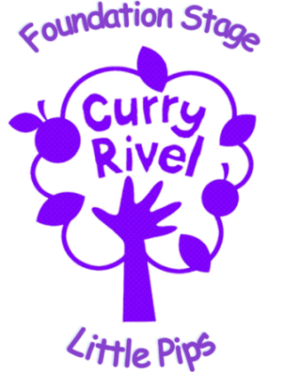

Personal Hygiene Policy

This policy outlines best practice for staff handling or preparing food.

Staff are expected to maintain a high standard of personal hygiene at all times.

All staff who regularly prepare or handle food are to complete a food handlers’ agreement, and attend all relevant training.

Prior to food handling, hand washing is one of the best ways to prevent harmful bacteria from spreading. Staff will wash hands when:

- Entering the kitchen
- Before touching ‘ready to eat’ foods
- After emptying bins
- After cleaning
- After touching a cut or changing a dressing/plaster
- After coughing or sneezing

Washing hands effectively

- Wet your hands thoroughly under warm running water, put liquid soap into the palm of your hands.
- Rub hands together to make a lather.
- Rub the palm of one hand along the back of the other and along the fingers. Then repeat with the other hand.
- Rub in between each of your fingers on both hands, round your thumbs and then your fingertips and nails.
- Rinse off the soap with clean water.
- Dry hands thoroughly on a disposable towel. Turn off the tap with the towel them throw the towel away.

Clothing & Jewellery

- Before entering a food preparation area or handling food ensure that all outer clothing (e.g. coats, jackets, scarves) have been removed and stored in the staff room.
- Hair that is longer than shoulder length must be tied back at all times when working within the Nursery.
- Staff regularly preparing food should not wear jewellery (wedding bands acceptable) because of the risk of spreading bacteria, or falling into food.
- Staff should put on Personal Protective Equipment (PPE). For example: an apron before preparing food

Good Practice

Staff will not drink or eat when preparing food, will avoid touching their face or hair. Harmful bacteria can be passed to food from someone’s face or mouth through the hands.

Fitness for work

Staff should be ‘fit for work’ at all times. This means they must not be suffering from, or carrying any illness or disease that could cause problems with food safety.

Any member of staff who has diarrhoea or vomiting must report it immediately to their supervisor or manager.

If any of the above occurs at home staff are to notify the manager that they are unfit for work and must not return until they have been symptom free for 48hours. Normal nursery reporting procedures apply.

Cuts and sores should be completely covered with a blue waterproof plaster. This is to prevent the bacteria from a cut or sore from spreading. Plasters are located in the main kitchen, staff room, nursery room and office.

If staff are suffering from any skin conditions such as psoriasis, dermatitis or eczema, or have a septic cut that may affect their ability to handle or prepare food safely they must inform their manager who may assign them to other duties.

Any person who has conjunctivitis, impetigo or a parasitic infection is to inform their manager and they will be excluded from food handling/preparation duties until it is safe to do so.

