Curry Rivel  Church of England  Primary School | 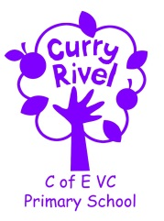  ‘‘Healthy Trees Bearing Good Fruit’ Matthew 7:7 | Maigold Class  Autumn Newsletter  September 2025
Dear Parents/Carers,

It is with great pleasure that I welcome you to the start of a new school year. I’m thrilled to be your children’s new teacher and excited to begin this journey of learning and growth together.

This term, we’ll be focusing on building a strong classroom community. Through games, stories, and shared activities, we’ll help the children settle in, make new friends, and feel confident in their new environment.

In this letter, you’ll find useful information about what your children will be learning, along with key dates and important updates for the school year.

If you ever have any questions or concerns, please feel free to contact me via the school office or speak to me at drop-off.

Best wishes,
Mr Rubino

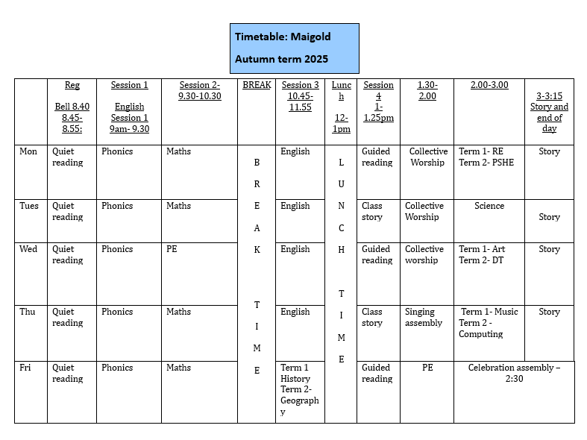

Support team
This is the team of adults who support Maigold class. Mrs Charlotte Monk is the school SENDCo. Mrs Taylor is the class TA
 |  | 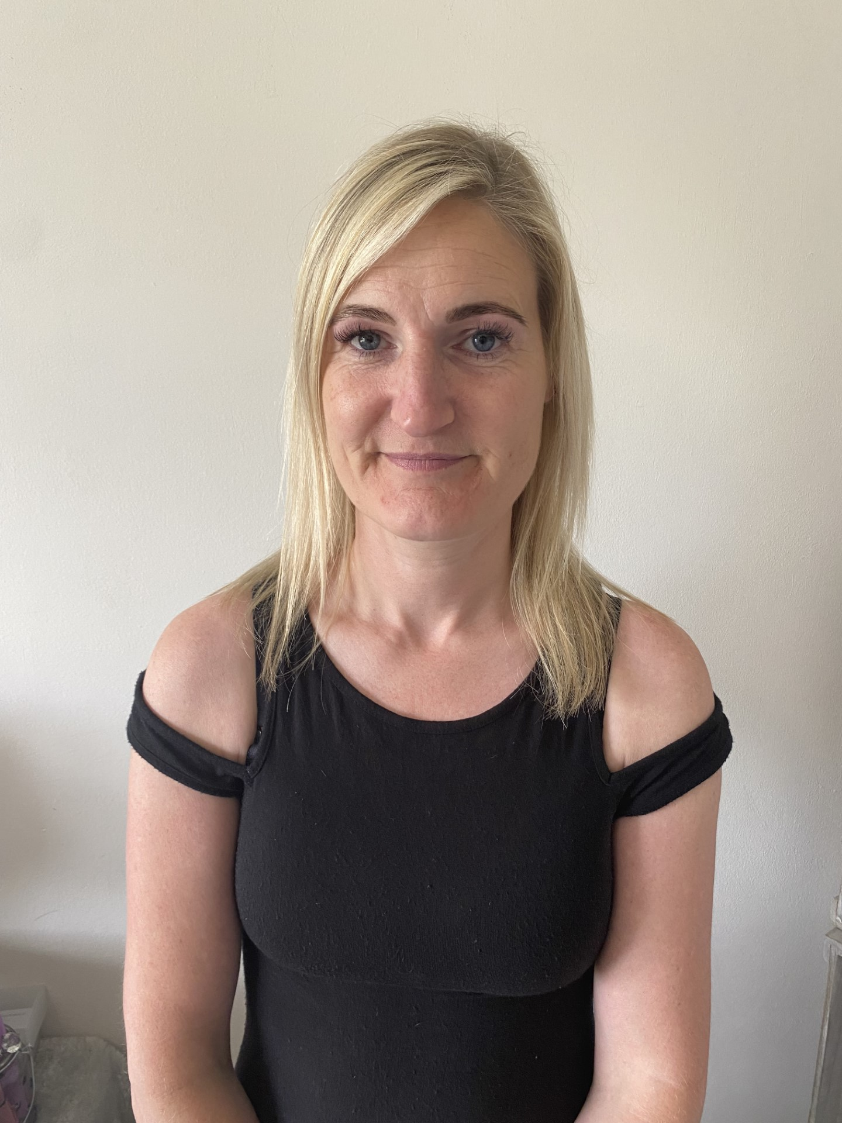
Mrs Monk




Mrs Z Cousins
Mrs P Griffin
Mrs Monk

Our Ambitious Curriculum at Curry Rivel Church of England Primary School

Our curriculum is a ‘knowledge-rich’ and ‘sticky’ curriculum, based on the teaching of core concepts and skills.
WHAT IS A KNOWLEDGE-RICH APPROACH?
‘The accumulated wealth of human knowledge, and what we choose to pass on to the next generation through teaching in our schools (the curriculum), must be at the heart of education’ (Amanda Spielman).
Knowledge underpins and enables the application of skills. We strive for children to learn skills alongside knowledge, ensuring that both are developed. At Curry Rivel Church of England Primary School and Little Pips Nursery we see knowledge and skills as intertwined. We believe that this is important for making the curriculum relevant and meaningful to pupils and for putting knowledge into context. We have looked at every curriculum area individually, as we recognise that each subject is unique and includes its own substantive knowledge, disciplinary knowledge and skills. We have sequenced the content of many of our subjects using ‘rolling programmes’ which ensure that whatever path a pupil takes through the school, the National Curriculum content is covered. More importantly, our curriculum is a ‘spiral curriculum’ in which key concepts are presented repeatedly throughout the curriculum, but with deepening layers of complexity.
In Maigold Class this term, we will be studying the following units of work:
English | Book: Beegu |  | Science | All about our bodies
Maths | Numbers and counting |  | Computing | Computing systems, networks, data and information
PE | Gymnastics and outdoor activities |  | Design Technology | Cooking and a balanced diet
Music | Musical symbols |  | Personal Social Health Economic Education (PSHE) | Online safety
RE | Why do we need to give thanks? |  | Geography | Where am I?
Art | Colour mixing |  | History | Timelines

PROMOTING READING
A good ability in reading is fundamental to everything that the children will learn in class during the year, and regular practice is therefore the most important aspect of homework that he or she will have. Please keep in touch with us if you are experiencing difficulties with helping your child with this vital regular activity. For our part, we will let you know if there is insufficient reading practice taking place. (Daily home reading is expected as least 5 times a week). Here are some top tips:
- All children need to read some of their book aloud to you whatever their ability
- Agree daily targets with your child. E.g. 10 pages or 20 minutes
- Discuss what your child is reading
- Read to your child regularly: this could be a book you have chosen together or could be your child’s school book.
- Record all home reading in the reading diary.

ACCELERATED READER
We use a reading scheme called Accelerated Reader for Key Stage 2, and for some pupils in Year 2, once they have progressed through the phonetically decodable books.
As the children bring their reading books home you will notice a system of levelling books. The number on the front of the book indicates the reading level (which has been determined by the results of a reading assessment that all the children have completed). This enables us to have a much firmer understanding of the children’s progress. You will also hear about ‘quizzes’. This enables the monitoring of the children’s comprehension and whether they’ve understood their reading – not just read the words. Throughout the term, we will continue to celebrate and support the children with their reading habits and their comprehension skills.
Your child’s decimal reading range corresponds to books, which aim to challenge your child yet be decodable without your child getting frustrated or losing understanding. Teachers will adjust reading ranges at their discretion.

Children should aim to score at least 80% on a quiz in school to show that they have generally understood their reading text.
If your child is concerned that they are finding this tricky, they could try any of these:
- Choose a shorter book.
- Choose a book, which they prefer and find more engaging.
- Ask to read more of their text with an adult, who will help them to infer the meaning of new vocabulary and show them how to summarise whilst reading.

PE Day: Wednesday and Friday
If your child is unable to do PE for any reason, please can you provide a note/letter or phone the school office. Pupils should wear their school PE kits into school on those days. School sweatshirts/cardigans please (No sports hoodies or sports tops). Jewellery and watches should not be worn for PE lessons. Earrings are not permitted to be worn and must be removed. As the term progresses and the weather stays cooler, black/navy tracksuit bottoms can be worn for outdoor PE. Please bare this in mind, as we will be doing PE outside for some topics.

Homework in Maigold Class
The most important homework you can do is reading, as least 5 times a week. It is vital that this aspect of the homework routine is established quickly. Please ensure a grown-up has signed each home read as this is checked on a Friday.

Personal belongings
Please ensure that your child’s belongings are all labelled with their name. We supply all the stationery your child needs so a pencil case is not required. Children should not bring toys and cuddly toys or other precious items to school.

Water bottles & Snacks
It is proven that children learn best when they are hydrated, so we encourage children to bring in a labelled bottle containing water for the classroom, each day. Ideally, a sturdy, sports cap re-useable bottle works best. The children are able to refill these throughout the school day. Children are encouraged to bring fruit or vegetables for a breaktime snack.

Communication
We can have quick conversations at drop-off and pick-up. If you require a longer or more sensitive conversation, please email the school (office@curryrivel.somerset.sch.uk) and your message will be forwarded to me You can also phone the school office to ask to speak with me. Please know that I am very willing to help you, answer any questions or tall through any issues.
We will be organising a parents’ evening later in term.

