Curry Rivel  Church of England  Primary School | 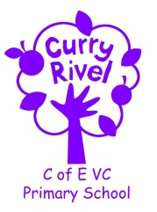  ‘Healthy Trees Bearing Good Fruit’ | Maigold Class  Autumn newsletter  September 2023
Dear Parents/Carers,

Welcome to Maigold Class and the new school year! It has been a pleasure to welcome the children back to our new class. I hope you have had a good rest and some quality time with your family.

It is hoped that this newsletter gives you a flavour of what you can expect from the term ahead. Communication is so important, and although the beginning/end of the day does not allow for long conversations, you can always contact me via the school office. We also have parents’ evening in the coming term but please do not hesitate to contact the school if you can help me to support your child.

I feel it is important that you have an understanding of what the school day looks like. Please see the timetable below, which illustrates a typical week in Maigold Class this term - this can be used to help you have conversations about what your child has been learning in school each day.
In Autumn 1, the children will have science, computing, history, art and PSHE.
In Autumn 2, the children will have science, geography, D.T. and Music.

Best wishes,

Miss Carnie

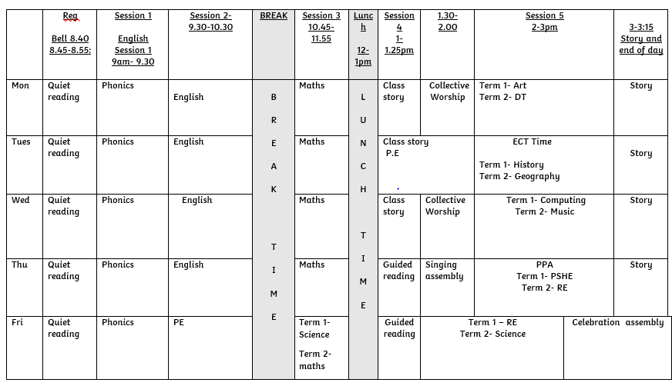

SUPPORT TEAM
It is always good to know which adults are working with and supporting our class, so here is the Maigold team:

Mrs Taylor is Maigold’s Teaching Assistant.
Miss Kilner will teach Maigold on a Tuesday afternoon to allow Miss Carnie to complete early career teacher training.
Mrs Langford is the school Emotional Literacy Support Assistant (ELSA).

In Maigold Class this term, we will be studying the following units of work:
English  Protection and conservation  Doing the right thing | Autumn 1-  The children will be writing own version narratives about aliens and fact files about being an astronaut.  Autumn 2-  The children will be writing story sequels and persuasive letters. |  | Science | In Science, the children will be learning about living things and their habitats.
Maths year 1 | - Previous reception experiences and counting within 100.  - Comparisons of quantities.  - Numbers 0-5 |  | Maths year 2 | - Numbers 10-100  - Calculations within 20  - Add and subtract within 10.  - Addition and subtraction of 2 digit numbers.
PE | Autumn 1-  Tuesday- Hit, catch, run.  Friday- Dance  Autumn 2-  Tuesday- Attack, defend, shoot.  Friday- Gymnastics. |  | Design Technology | In DT, the unit theme is based on making a moving monster. The children will plan and design a monster that moves using a mechanism.
Music | In music, the children will be learning new songs for the nativity. |  | PHSE | In PSHE, the children will be learning about online safety
RE | In RE, We will be thinking about the question ‘What do Christians believe God is like?’. |  | Geography | In Geography, we are going to be learning about how the weather affects our lives.
Phonics | Phase 5 learning |  | History | In history, the children are going to be learning about changes in technology.
Art | In art, we are going to be exploring the formal elements of art: pattern, texture and tone. The children will learn how to make their drawings three dimensional. |  | Computing | In Computing, the children will be learning about technology in the world around us.

Supporting reading at home:
Daily home reading is expected as least 4 times a week. Reading records and books will be monitored/changed 3 times a week. Monday, Wednesday and Friday. Books will be changed if your child has finished their book and read it more than once. Please sign or initial and record any comments or unfamiliar vocabulary, which will help school to build on the reading you are doing at home. If your child does not read at least 4 times over the week, the children will read during Friday lunchtime and an adult will listen to them read to support their reading development. Please do not hesitate if you need support with assisting reading at home.
In order for children to become confident, fluent and enthusiastic readers, it is essential that we teach and give them opportunities to develop all of these skills.
For our early readers, this will mean using different books in different ways:
You can focus your 4 reads a week on these skills.
1. Child to use word recognition, segmenting and blending the text to read aloud.
2. Fluency and prosody- Child and adult reads modelling fluency and expression using a storyteller voice.
3. Adult/child to read together discussing vocabulary throughout.
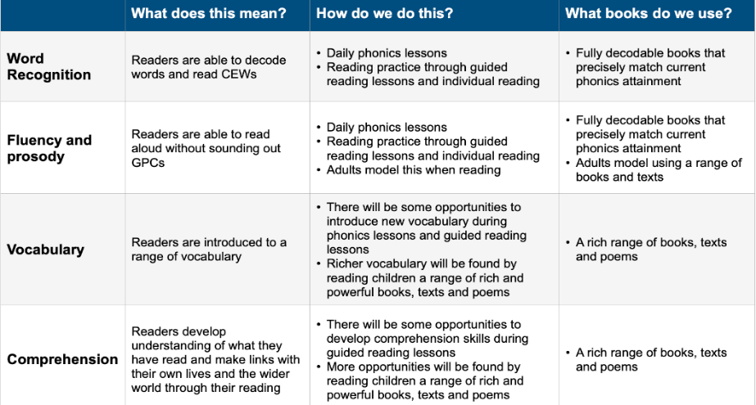
4. Child to re-read the book making sense of what has been read.
As well as the given decodable books encourage your child to read/ share a variety of fiction, non-fiction and poetry, including children’s newspapers, magazines, signs and displays.

ACCELERATED READER
We use a reading scheme called Accelerated Reader for Key Stage 2, and for some pupils in Year 2. As the children bring their reading books home you will notice a system of levelling books. The number on the front of the book indicates the reading level (which has been determined by the results of a reading assessment that all the children have completed). This enables us to have a much firmer understanding of the children’s progress. You will also hear about ‘quizzes’. This enables the testing of the children’s comprehension and whether they’ve understood the book. Throughout the term we will able to monitor the children’s reading habits and their comprehension skills, and can adjust their levels as they improve.
PE
Maigold class will have their PE lesson a Tuesday afternoon with Miss Kilner and a Friday morning with Miss Carnie.
If your child is unable to do PE for any reason, please can you provide a note/letter or phone the school office. Pupils should wear their school PE kits into school on a Friday. Jewellery and watches should not be worn for PE lessons. As the term progresses and the weather gets colder, black tracksuit bottoms and the school jumper/cardigan can be worn for outdoor PE. We will be doing PE outside at least once a week, on top of the daily mile, in all weather conditions.

Water bottles & Snacks
It is proven that children learn best when they are hydrated, so we encourage children to bring in a labelled bottle containing water for the classroom, each day. Ideally, a sturdy, sports cap re-useable bottle works best. The children are able to refill these throughout the school day. Fruit will be provided for children in Maigold class or children can bring their own fruit in from home for break.

Personal belongings
Please ensure that your child’s belongings are all labelled with their name. We supply all the stationery your child needs so a pencil case is not required. Children should not bring toys and cuddly toys or other precious items to school.

Homework in Maigold Class.
READING: The most important homework you can do is reading, as least 4 times a week. It is vital that this aspect of the homework routine is established quickly. Please record the pages/book read and sign in the yellow reading record. Phonic books are changed on Monday Wednesday and Friday and the reading record is also checked on these days. Your child will receive a merit if they have read at least 4 times a week and 2 merits if they have read more than 4 times.

Communication
Please email the school (office@curryrivel.somerset.sch.uk) and your message will be forwarded to me. You can also phone the school office to ask the class teacher to call you if you prefer.

