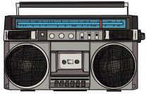

**Changes in Technology**

# 

**A timeline to help us**

**Key history vocabulary to help us**

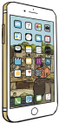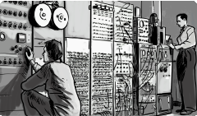

* recently existed
* at an earlier time

**new**

**before**

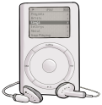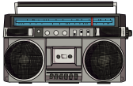

* at that past time
* later in time

**after**

**then**

* in these times, or at this time
* having happened or gone by at an earlier time

**past**

**now**

* identical, similar, not different
* happening now, in this time

**same**

**present**

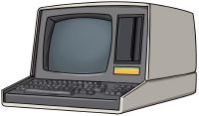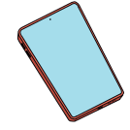

* not the same as another
* something not new that has existed before

**different**

**old**

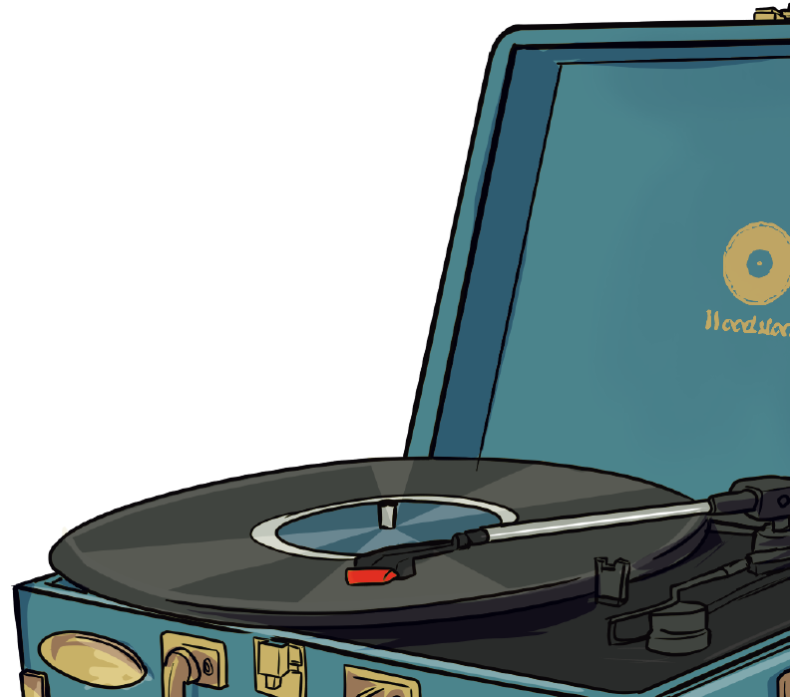

**Changes in how we write**

**Changes in how we are entertained**

**How do we find out about the past?**

**Changes in how we talk**

**Sixty years ago,** the **typewriter** was the main form of written communication apart from by hand. Technology has advanced over the years, and how we write has changed. After the typewriter came the **Personal Computer (PC).** Along with the invention of the internet and then the **World Wide Web by Tim Berners-Lee,** people could send emails, which meant they could send the written word anywhere in the world. Next came **laptops,** which could be taken with you wherever you worked. Then an American computer scientist called Alan Kay introduced the tablet, and now in the **modern day,** people can write, send emails and even print, all from their **mobile phones.**

**Sixty years ago**, some people had a telephone in their homes, but it would have looked **different** to our **modern-day** telephones. They were called **rotary** telephones. If people didn’t have a phone in their homes, they would have used a public **telephone box** to make their calls.

In the **modern day**, we use our home phones and **mobile phones** to make calls, and we can **video call** people anywhere in the world. This means we can see their faces as well as hear their voices. This is all possible because of **advances in technology.**

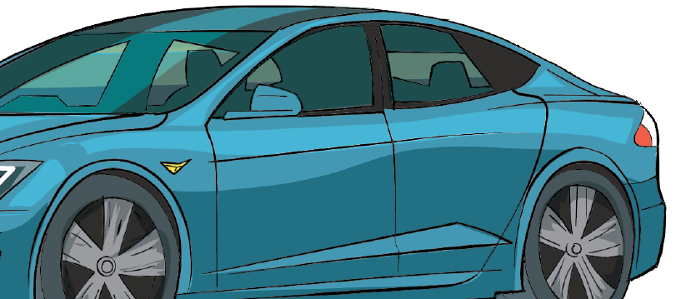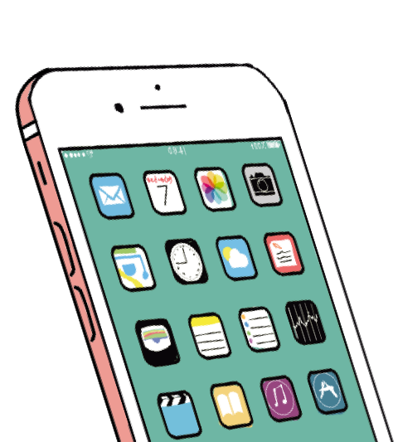

**Sixty years ago,** people had **televisions** in their homes. The picture was in black and white, and there were only three channels to choose from: BBC1, BBC2 and ITV. Colour television was introduced in 1967.

In the **1970s,** people began playing **video games** on a television set.

**Portable music** devices were available in the **1980s** as people began to listen to their favourite music through headphones.

**Today,** much of our entertainment comes from our **SMART TVs, gaming consoles** and **mobile phones.**

## We can find out about the past by:

* looking at and reading non-fiction books
* searching the internet
* talking to people who were around at the time that we want to find out about
* watching video clips or TV shows about the time in history we want to find out about
* visiting museums
* looking at photographs
* looking at objects from the past



www.grammarsaurus.co.uk