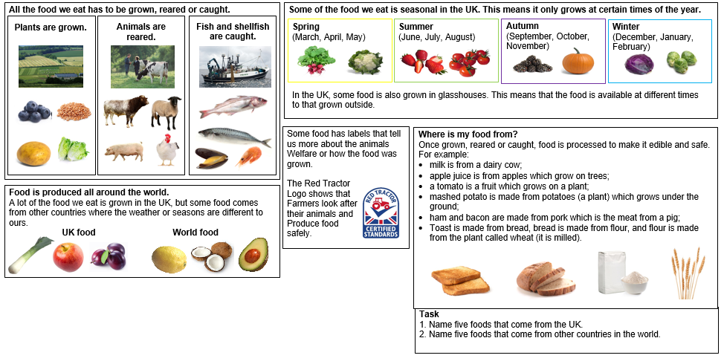
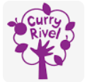
Knowledge Organiser – Geography – Understanding the world – Why does it matter where our food comes from? – Pippin Class – Spring

