|  |  |  |
| --- | --- | --- |
| **Curry Rivel**  **Church of England**  **Primary School** | ***O:\New Logo and Web Images\JPEG\CR logo Purple +txt_renamed_32721.jpg***  ***‘Healthy Trees Bearing Good Fruit’*** | **Pippin Class**  **Autumn newsletter**  **September 2024** |
| Dear Parents/Carers,  It has been a pleasure to welcome you all to Curry Rivel Primary School this week. The children have settled in fantastically and already we are excited to see what the year will bring. It has been a pleasure to get to know your children; their enthusiasm and curiosity has already shone through and we are looking forward to support and watch them grow over the next academic year.  It is hoped that this newsletter gives you a flavour of what you can expect from the term ahead. Communication is so important, and although the beginning/end of the day does not allow for long conversations, you can always contact me via the school office or tapestry. We also have parents’ evenings in the coming term but please do not hesitate to contact the school if you can help me to support your child.  I feel it is important that you have an understanding of what the school day looks like. Please see the timetable below, which illustrates a typical week in Pippin Class this term - this can be used to help you have conversations about what your child has been learning in school each day.  Best wishes,  Mrs Davies-Evans (Mon, Tue, Thu, Fri) and Miss Kilner (Wednesdays) | | |

|  |  |
| --- | --- |
| **SUPPORT TEAM**  C:\Users\ellie.martin\Downloads\ID badge.jpg  Mrs Myhill Mrs Trott Mrs Shaw Mrs Langford Mrs Monk   |  | | --- | | This is the team of adults who support Pippin class. Mrs Shaw will teach Pippin class on Thursday afternoon so that Mrs Davies-Evans can have her planning time. Mrs Myhill will be helping in Pippin class with Mrs Trott who is a 1.1 TA, Mrs Langford is the school ELSA (Emotional Literacy Support Assistant) and Mrs Monk is the school SENDCo. | |

Please see below the curriculum overview to see what this year may look like.

Also attached is a planning document to see what our learning will look like this half term, during our topic ‘All about me’ and how it links to each area of development of the Early Years Foundation Stage.

You will also have a knowledge organiser attached. This is a document with key learning points to which you can use to support your child at home. It will also provide suggestions for extra activities linking to our topic.

**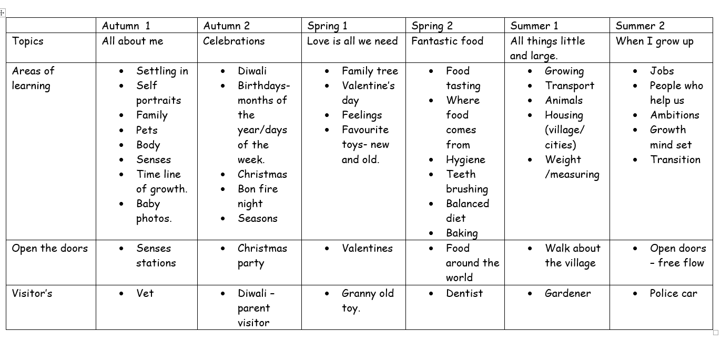**

**Supporting reading at home:**

Daily home reading is expected as least 4 times a week. Reading records and books will be monitored/changed 3 times a week. Monday, Wednesday and Friday. Books will be changed if your child has finished their book and read it more than once. Please sign or initial and record any comments or unfamiliar vocabulary, which will help school to build on the reading you are doing at home. If your child does not read at least 4 times over the week, the children will read during Friday lunchtime and an adult will listen to them read to support their reading development. Please do not hesitate if you need support with assisting reading at home.

In order for children to become confident, fluent and enthusiastic readers, it is essential that we teach and give them opportunities to develop *all* of these skills.  
  
For our early readers, this will mean using different books in different ways:

You can focus your 4 reads a week on these skills.

1. Child to use word recognition, segmenting and blending the text to read aloud.

2. Fluency and prosody- Child and adult reads modelling fluency and expression using a storyteller voice.

3. Adult/child to read together discussing vocabulary throughout.

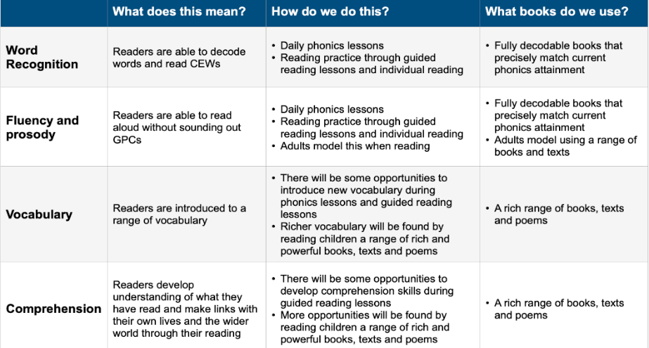4. Child to re-read the book making sense of what has been read.

**As well as the given decodable books encourage your child to read/ share a variety of fiction, non-fiction and poetry, including children’s newspapers, magazines, signs and displays.**

**Key dates:**

10th October – Phonics workshop afternoon 2.30-3.15pm.

14th October - Little Pips and Pippin class will share a session together discovering our senses.

|  |
| --- |
| **PE**  Pippin class will have their PE lesson on **Wednesday** and **Friday** afternoon.  If your child is unable to do PE for any reason, please can you provide a note/letter or phone the school office. Pupils should wear their school PE kits into school on a Monday and Thursday. Jewellery and watches should not be worn for PE lessons. As the term progresses and the weather gets colder, black tracksuit bottoms and the school jumper/cardigan can be worn for outdoor PE. |

|  |
| --- |
| **Water bottles & Snacks**  It is proven that children learn best when they are hydrated, so we encourage children to bring in a labelled bottle containing water for the classroom, each day. Ideally, a sturdy, sports cap re-useable bottle works best. The children are able to refill these throughout the school day. Fruit will be provided for children in Pippin class or children can bring their own fruit in from home for break. This is a fruit or vegetable snack only. |

|  |
| --- |
| **Personal belongings**  Please ensure that your child’s belongings are all labelled with their name. We supply all the stationery your child needs so a pencil case is not required. Children should not bring toys and cuddly toys or other precious items to school. |

|  |
| --- |
| **Homework in Pippin Class**.  **READING**: The most important homework you can do is reading, as least 4 times a week. It is vital that this aspect of the homework routine is established quickly. Please record the pages/book read and sign in the reading record. Phonic books are changed on Monday Wednesday and Friday and the reading record is also checked on these days. Your child will receive a merit if they have read at least 4 times a week and 2 merits if they have read more than 4 times. |

|  |
| --- |
| **Communication**  Please email the school (office@curryrivel.somerset.sch.uk) and your message will be forwarded to me. Or contact me via tapestry. You can also phone the school office to ask the class teacher to call you if you prefer. |