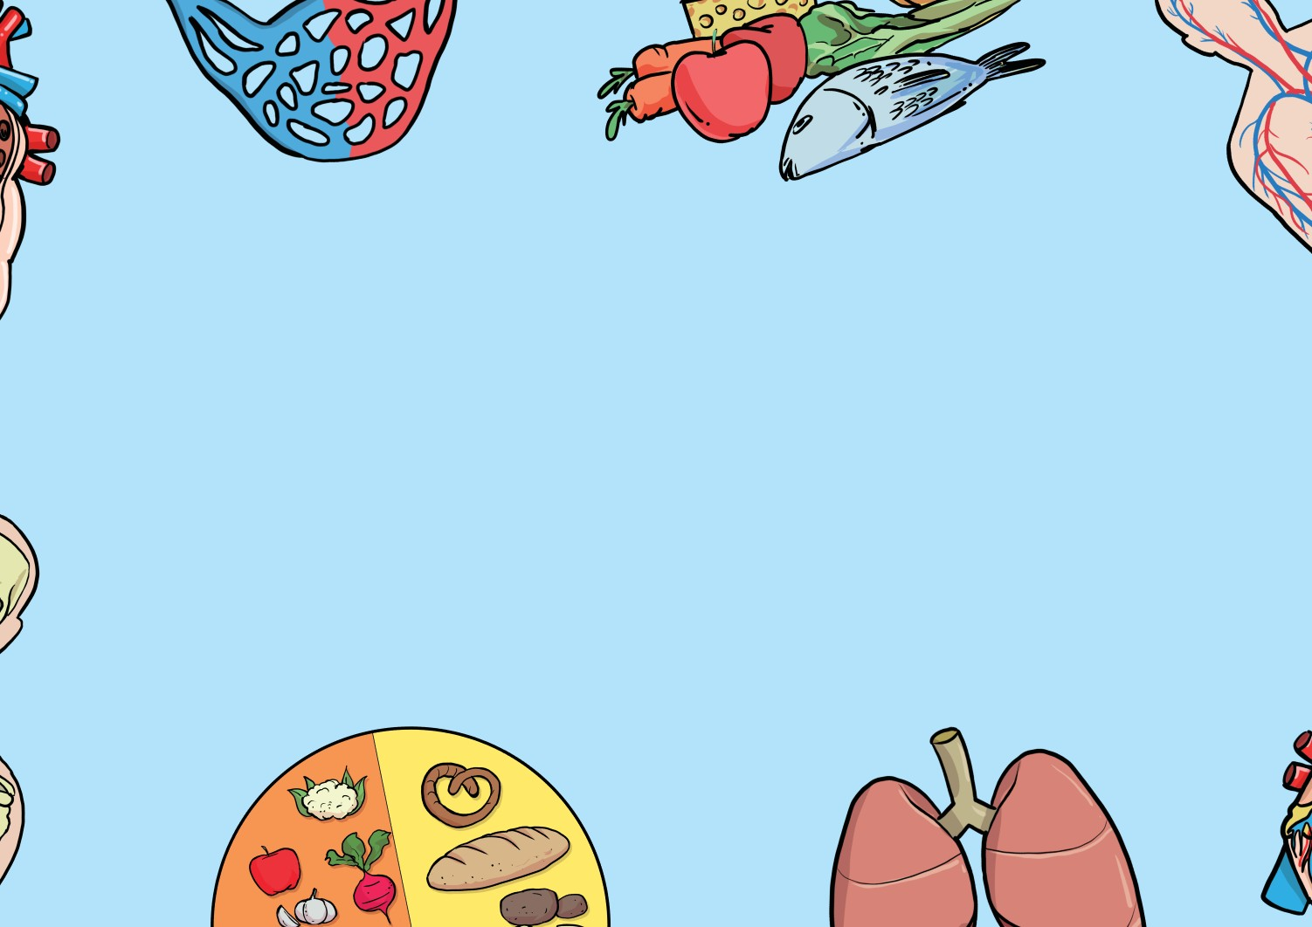
Digestive Organs and their functions
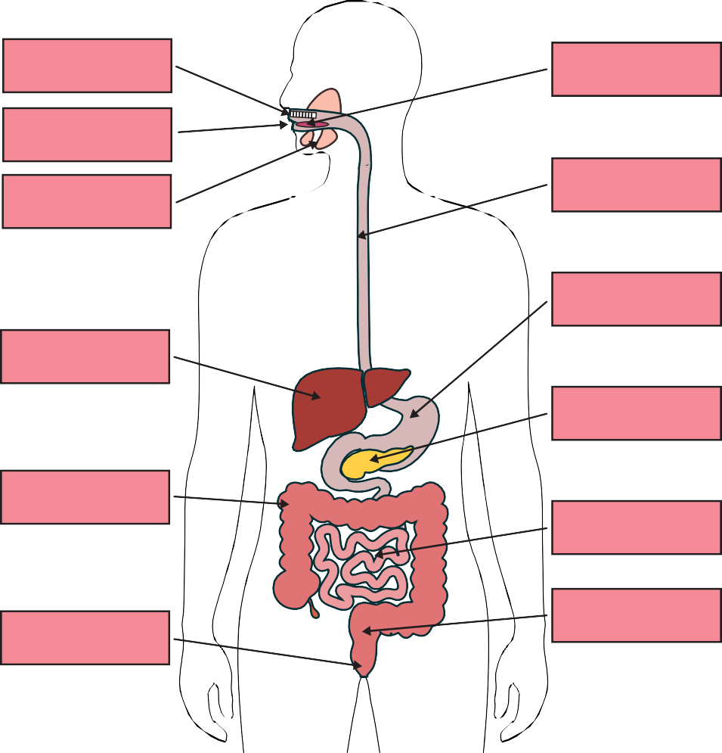
The Digestive System
teeth
tongue
mouth
salivary glands
oesophagus
stomach
liver
pancreas
large intestine
small intestine
anus
rectum
Organ | Function
mouth | where food enters the digestive system
teeth | tear, rip and chew food
salivary glands | produce saliva
tongue | moves the food into a bolus and pushes it to the oesophagus
oesophagus | a muscular tube which uses contractions to move the bolus from mouth to stomach
stomach | mix with acid and enzymes to turn food into a paste
liver | produces bile to break down fat
pancreas | produces enzymes which break down fats, proteins and carbohydrates
small intestine | absorbs nutrients from the food
large intestine | helps absorb water from the food
rectum | holds the stool until you go to the toilet
anus | where the stool is released

grammarsaurus.co.uk

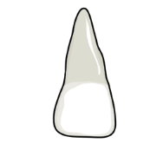
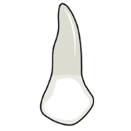
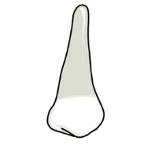
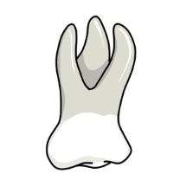
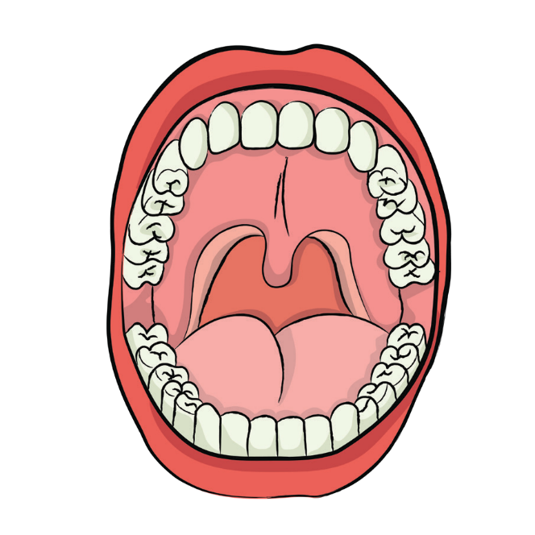
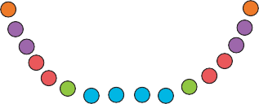
Teeth and their functions
Teeth
Key incisors canines
premolars molars
wisdom
Incisors - We have eight incisors: four on the top jaw and four on the bottom. They are flat and are sometimes described as spade shape. These are the teeth we usually use first when eating. They are used for biting and cutting food.
Canines - We have four canines: two on the top jaw and two on the bottom. Our canines are pointy and sometimes referred to as ‘fangs’. We use our canines to tear and rip our food.
Pre-molars - We have eight premolars: four on the top jaw and four on the bottom. They are next to our canines. Our premolars are small and have a flat top. They hold and crush our food.
Fascinating Facts!
- You have two sets of teeth in your lifetime.

- Adults have 32 teeth whilst children only have 20.

- Our stomach can stretch. An adult’s stomach can hold approximately 1.5 litres of food and drink.
- Our oesophagus is approximately 25cm long.

- It takes 7 seconds for food to travel to the stomach once you have swallowed it.

- Scientists believe we have wisdom teeth because our ancestors used to eat a lot of tougher food, such as leaves and nuts, which needed grinding more.
Molars - We have eight molars: four on the top jaw and four on the bottom. The molars towards the back of our mouths. They are our largest teeth and have a flat top. They are used to grind out food before we swallow it.
Wisdom - When we get older, most of us will grow our wisdom teeth. We have four wisdom teeth. Our wisdom teeth are just an extra molar, so they help with grinding our food. We don’t necessarily need our wisdom teeth nowadays, and many people have them removed as our mouths aren’t big enough to house them!

grammarsaurus.co.uk

