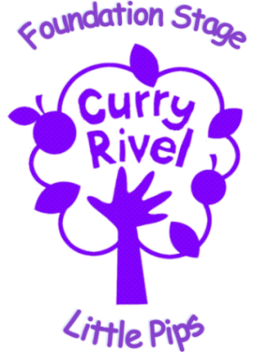

Bottle Policy

Parent and Practitioner Formula Milk Preparation and Feeding Guidelines

Staff at The Nest @ Little Pips follow guidelines for preparing formula milk for infants in accordance with policy published by The Food Standards Agency and The Department of Health.

We ask that parents help with this in the following ways:

Bring in your infant’s bottle sterilised and fully assembled with the teat and lid in place. This prevents the inside of the sterilised bottle and the inside of the teat from being contaminated. (Alternatively the Nursery can provide a fully-sterilised bottle for feeding baby, if required)

Provide the formula powder inside its original container: this is the best way for practitioners to ensure they are preparing feeds correctly, in accordance with the guidelines detailed on the packet or tin.

Label to formula container with child’s full name and date of opening

According to the Food Standard Agency and Department of Health, the best way to prevent a baby becoming ill is to make up all formula feeds fresh, as and when they are required by the baby.
The Nest @ Little Pips will follow the routine below to ensure best practice when carrying out the task:

- Clean the surface thoroughly on which to prepare the feed.
- Wash hands with soap and water and then dry.
- Use the bottle prep machine to ensure bottles are made to the correct temperature
- Add the exact amount of formula as instructed on the label.
- Re-assemble the bottle following manufacturer’s instructions.
- Shake the bottle well to mix the contents.
- If necessary ; cool quickly to feeding temperature by holding under a running tap
- Check the temperature by shaking a few drops onto the inside of your wrist – it should feel lukewarm, not hot.
- Discard any feed that has not been used within two hours.

In line with the nursery Food and Drink policy, we are unable to reheat or serve pre-prepared formula brought in from home. We recognise that parents may wish to provide pre-prepared milk in sealed cartons so when re-warming milk feeds for babies, the practitioners will carry out the following guidelines:

- Transfer the formula to a sterile bottle
- Re-warm using a bottle warmer, or by placing in a container of warm water. (In accordance with the Food Standard Agency and the Department of Health: Microwaves should not be used for re-warming a feed.)
- Shake the bottle to ensure the feed has heated evenly.
- Check the feeding temperature by shaking a few drops onto the inside of the wrist – it should be lukewarm, not hot.
- Bottles should not be warmed for more than 15 minutes, any feed left heating for more than 15 minutes should be disregarded.

