Curry Rivel  Church of England  Primary School | 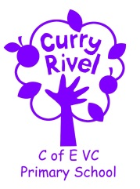  ‘Caring, curious and confident’ | Blenheim Class  Autumn Newsletter  September 2023
Dear Parents/Carers,

Welcome to Blenheim Class and the new school year; I have really enjoyed welcoming the children into Year 6 and getting to know them over the first few days. I hope you have had a brilliant rest and enjoyed some quality time with your families. It is exciting to be back to school in our new class, ready for the children’s final adventure at Curry Rivel, and I am really looking forward to the challenges and experiences we will face together this year.

I hope that this newsletter gives you an idea of what you can expect from the term ahead. Communication is so important, and although the beginning/end of the day does not always allow for long conversations, you can always contact me via the school office. We will also have parents’ evening before the half term break.

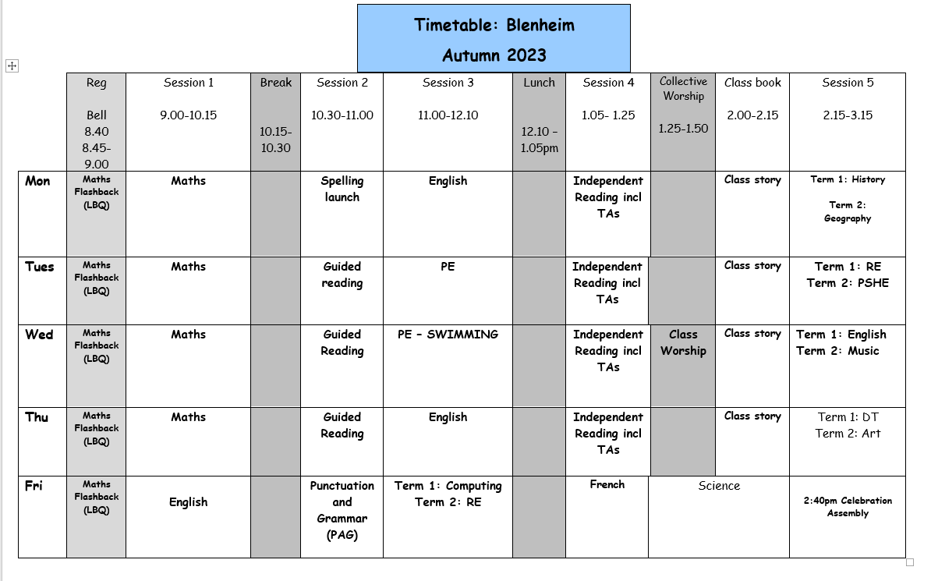
I feel it is important that you have an understanding of what the school day looks like. Please see the timetable below, which illustrates a typical week in Blenheim Class this term- this can be used to help you have conversations about what your child has been learning in school each day.

I look forward to working together to support your child to develop and grow, nurturing and building on their fantastic Primary learning so far, and, most importantly, helping them to grow as a person. I really hope your child enjoys their time in Blenheim Class.

Mr Bridgeman


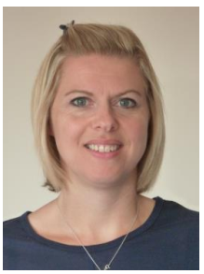


SUPPORT TEAM
It is always good to know which other adults are supporting our class, so here is the support team:

Mrs Shaw is our class Teaching Assistant
Mrs Monk is the school SENDCo
Mrs Langford is the school ELSA (Emotional Literacy Support Assistant) across the school.
Mrs Langford will be teaching PSHE to the class during teacher planning time on Tuesday afternoons. After half-term, Mrs Shaw will take over with RE.

Mrs Monk
Mrs Langford
Mrs Shaw
English | - Narratives based on ‘’The Arrival’ by Shaun Tan  - Persuasive Writing based on ‘The Last Bear’ by Hannah Gold  - Guided Reading units based on ‘On the Move’ by Michael Rosen and ‘Darwin’s Voyage of Discovery’ by Jake Williams. |  | Science | Evolution & Inheritance
Maths | Calculating using knowledge of structures, multiples of 1,000 and numbers up to 10,000,000. |  | Computing | Computing Systems & Networks
PE | Netball, Swimming, Gymnastics & Hockey |  | Design Technology | Come Dine With Me – Cooking three courses
Music  Art | Music & Technology  Craft & Design with photo opportunities |  | Personal Social Health Economic Education (PSHE) | - Online Safety
RE | Passover |  | History | Crime & Punishment
French | Past & Present tense |  | Geography | How do volcanoes affect the lives of people?
Please see the Knowledge Organisers for Maths, Science, History and DT (sent out separately) and use to discuss what your child is learning in school; you can use a Knowledge Organiser in different ways: Read through it together; discuss tricky vocabulary; quiz your child on the knowledge they have acquired; play true and false games with the facts.
Our Ambitious Curriculum at Curry Rivel Church of England Primary School

We aim for all our pupils to be ‘Caring, Curious and Confident’ learners. Our curriculum is a ‘knowledge-rich’ and ‘sticky’ curriculum, based on the teaching of core concepts and skills.
What is a KNOWLEDGE-RICH APPROACH? ‘The accumulated wealth of human knowledge, and what we choose to pass on to the next generation through teaching in our schools (the curriculum), must be at the heart of education’ (Amanda Spielman).
Knowledge underpins and enables the application of skills. We strive for children to learn skills alongside knowledge, ensuring that both are developed. At Curry Rivel Church of England Primary School and Little Pips Nursery we see knowledge and skills as intertwined. We believe that this is important for making the curriculum relevant and meaningful to pupils and for putting knowledge into context.
We have looked at every curriculum area individually, as we recognise that each subject is unique and includes its own substantive knowledge, disciplinary knowledge and skills. We have sequenced the content of many of our subjects using ‘rolling programmes’ which ensure that whatever path a pupil takes through the school, the National Curriculum content is covered. More importantly, our curriculum is a ‘spiral curriculum’ in which key concepts are presented repeatedly throughout the curriculum, but with deepening layers of complexity.
PROMOTING READING
A good ability in reading is fundamental to everything that the children will learn in class during the year, and regular practice is therefore the most important aspect of homework that he or she will have. Please keep in touch with us if you are experiencing difficulties with helping your child with this vital regular activity. For our part, we will let you know if there is insufficient reading practice taking place. (Daily home reading is expected as least 4 times a week). Here are some top tips:
- All children need to read some of their book aloud to you whatever their ability
- Agree daily targets with your child. E.g. 10 pages or 20 minutes
- Discuss what your child is reading
- Read to your child regularly: this could be a book you have chosen together or could be your child’s school book.
- Record all home reading in the reading diary.
ACCELERATED READER
The number on the front of a book indicates a child’s reading level (which has been determined by the results of a reading assessment that all the children have completed). This enables us to have a much firmer understanding of the children’s progress. You will also hear about ‘quizzes’. This enables the monitoring of the children’s comprehension and whether they’ve understood their reading – not just read the words. Throughout the term, we will continue to celebrate and support the children with their reading habits and their comprehension skills.
Your child’s decimal reading level corresponds to books, which aim to challenge your child yet be decodable without your child getting frustrated or losing understanding.
Children should aim to score at least 80% on a quiz in school to show that they have generally understood their reading text.
If your child is concerned that they are finding this tricky, they could try any of these:
- Choose a shorter book.
- Choose a book, which they prefer and find more engaging.
- Ask to read more of their text with an adult, who will help them to infer the meaning of new vocabulary and show them how to summarise whilst reading.
When children have read approximately 3 books
(with a quiz of 80% or more), they will likely move up another tenth.
PE Day: Tuesdays (In School) & Wednesdays (Swimming).
In Autumn 1, we will be doing PE at school on a Tuesday and Swimming at Huish on a Wednesday. After October half term, we will have two PE lessons in school per week, on the above days. If your child is unable to do PE for any reason, please can you provide a note/letter or phone the school office. Pupils should wear their school PE kits into school on the above day. School sweatshirts/cardigans please (No sports hoodies or sports tops). Jewellery and watches should not be worn for PE lessons.

Water bottles & Snacks
It is proven that children learn best when they are hydrated, so we encourage children to bring in a labelled bottle each day containing water for the classroom. Ideally, a sturdy, sports cap re-useable bottle works best. The children are able to refill these throughout the school day. Children are encouraged to bring fruit, vegetables or a sandwich for a breaktime snack.

Personal belongings
Please ensure that your child’s belongings are all labelled with their name. We supply all the stationery your child needs so a pencil case is not required. Children should not bring toys and cuddly toys or other precious items to school.

Homework in Blenheim
The most important homework you can do is reading, as least 4 times a week. It is vital that this aspect of the homework routine is established quickly. Please ensure a grown up has signed each home read as this is checked on a Friday.

Times Tables are a crucial skill for the children as they move forward through their education. The children in Blenheim should log on to Times Table Rockstars (log-ins are in Reading Records) and play for at least 20 minutes per week; as above, this is checked on a Friday.

As we progress through the year, any additional homework will be set to prepare Year 6 children for their SATs and for secondary school routines. More information on this will follow.

Communication
Please email the school (office@curryrivel.somerset.sch.uk) and your message will be forwarded to me. You can also phone the school office to ask the class teacher to call you if you prefer. We appreciate that there is a wonderful family atmosphere here, and not being able to linger for chats is hard. You have been very complimentary about how we have kept you informed over the past year- continuing this will be vital. We will be organising a parents’ evening before half term.

