|  |  |  |  |  |  |
| --- | --- | --- | --- | --- | --- |
| *Communication and Language* | | *Personal, Social and Emotional Development* | | *Physical Development* | |
| -Hobbies:Describe some events in detail  - Hobbies: To engage in Non fiction books  - Retell the story, once they have developed a deep familiarity with the text, some as exact repetition and some in their own words.  -Engage is story time. Key texts –   * Guess how much I love you, * Large family * Love monster * Scarecrows wedding * Love umbrella   Poems and songs –   * You are my sunshine, * Love is important by Jean Kay.   Treasure box -using full sentences, including use of past, present and future tenses and making use of conjunctions, with modelling and support from their teacher. | | *-H*ow to love ourselves- Healthy diets/teeth hygiene  -How things your love makes you feel:   * Identify and moderate own feelings socially and emotionally.   • Think about the perspectives of others.  See themselves as a valuable individual.  • Build constructive and respectful relationships.  • Express their feelings and consider the feelings of others. | | -Begin to show accuracy and care when drawing   * Family representations   • Hold a pencil effectively in preparation for fluent writing – using the tripod grip in almost all cases- Handwriting lessons.  -Responding to music   * Move energetically, such as running, jumping, dancing, hopping, skipping and climbing. | |
|  | | | | | |
| *Literacy* | *Mathematics* | | *Understanding the World* | | *Expressive Arts and Design* |
| •Valentines cards  - Write short sentences with words with known letter-sound correspondences   * using a capital letter and full stop. * Re-read what they have written to check that it makes sense.   -Anticipate key events in stories | -Hearts patterns painting  -Comparisons of size between objects  (treasure box). | | -Talk about members of their immediate family and community. • Name and describe people who are familiar to them.   * Comment on images of familiar situations in the past * Compare and contrast characters from stories, including figures from the past   Draw information from a simple map – Chinese New Year  • Describe what they see, hear and feel whilst outside- What is love – wonderful world. | | - Listen attentively, move to and talk about music, expressing their feelings and responses.  -Watch and talk about dance and performance art, expressing their feelings and responses.  -Explore and engage in music making and dance, performing solo or in groups.  -Junk modelling – Animals we love  Clay model heart – A gift for someone else. |

Vut out  
Wee

English key texts:

Weirdo – Zadie Smith

Nick Laird

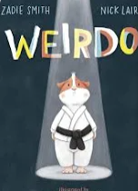

Autumn 2 phonics progression:

ow oi ear air ure er

Read: are, my, her,

Three (Mastery)

NCETM Maths:

Composition and comparison

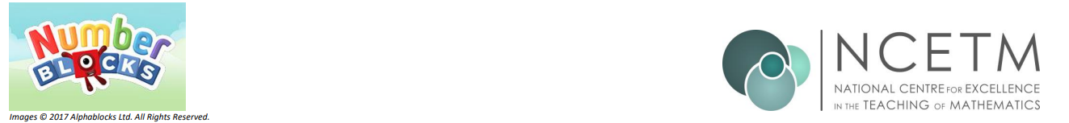

Open the doors with Little Pips

Valentines

11/2/2025

DT-Junk Modelling

RE- Special places

Music- Music and Movement.

PE- Gymnastics and speed Agility/travel.

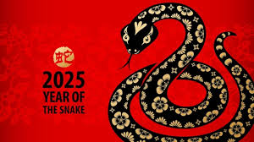C

https://www.bbc.co.uk/cbeebies/watch/my-first-festivals-chinese-new-year

https://www.youtube.com/watch?v=dh7LJDHC

Can you explore who is in your family tree?

Love is a positive attitude towards someone or something. It means that you like it. And you enjoy playing, communicating, or doing something else with a person or thing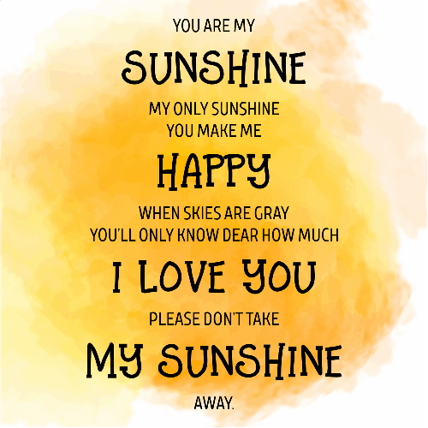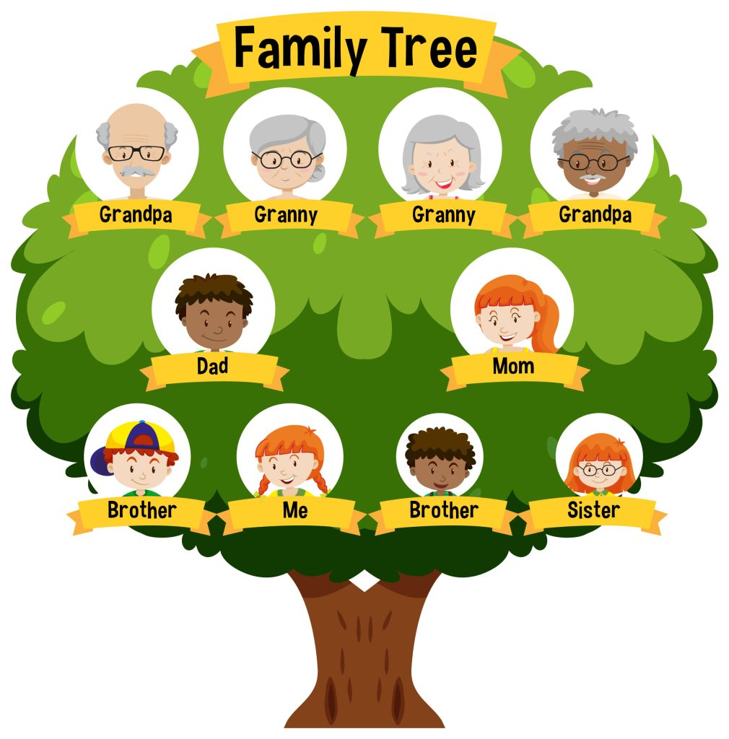

<https://www.youtube.com/watch?v=dh7LJDHFaqA>

Poem

<https://www.youtube.com/watch?v=78-K_Wbp0pM>