Curry Rivel  Church of England  Primary School | 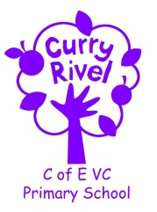  ‘Healthy Trees Bearing Good Fruit’ | Gala Class  Spring Newsletter  January 2024
Dear Parents/Carers,

Welcome back! We hope you have had the opportunity to enjoy some time together this Christmas and we wish you a happy New Year. We are excited for the new Spring Term and cannot wait to get started with our learning.
It is hoped that this newsletter gives you a flavour of what you can expect from the term ahead. Communication is so important, and although the beginning/end of the day does not allow for long conversations, you can always contact us via the school office.
It is important that you have an understanding of what the school day looks like. Please see the timetable below, which illustrates a typical week in Gala Class this term. This can be used to help you have conversations about what your child has been learning in school each day.

Best wishes

Mrs Samuel and Mrs van Cole

Mrs Samuel teaches Monday and Tuesday. Mrs van Cole teaches Wednesday, Thursday and Friday.

Support team
This is the team of adults who support Gala class. Mrs Myhill and Miss Laurence are our Teaching Assistants. Mrs Langford is the school ELSA (Emotional Literacy Support Assistant) and Charlotte Monk is the school SENDCo.

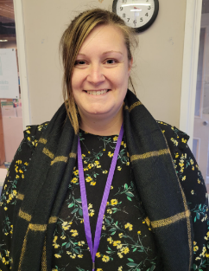

Mrs Myhill Miss Laurence Mrs Langford Mrs Monk

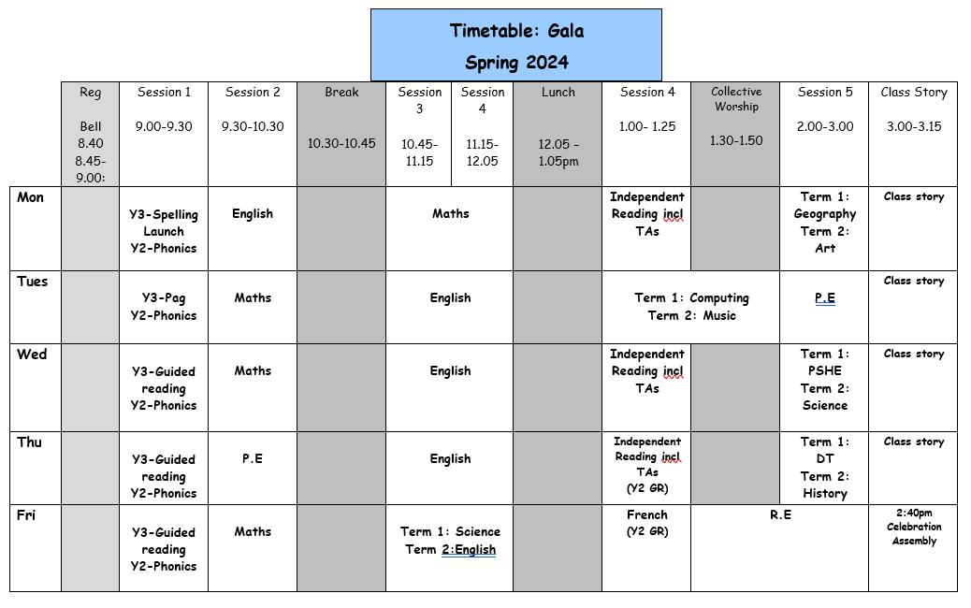

In Gala Class this term, we will be studying the following units of work:
English | Spring 1-Tenacity and determination  Leaflets for local landmarks  Spring 2- Magic and Mystery  News reports and extended narratives |  | Science | Rocks
Maths | Multiplication  Division  Statistics  Measurement |  | Computing | Programming- Sequencing sounds
PE | Spring 1- OAA, Football  Spring 2- Swimming and Hockey |  | Design Technology | Structures- Castles
RE | What do candles mean to different people? |  | Personal Social Health Economic Education (PSHE) | Health and Wellbeing
Music | Compose using your imagination |  | Geography | How can we live more sustainably?
Art | Craft and design: Ancient Egyptian Scrolls |  | French | Jeux et chansons- Games and Songs
History | The Great Plague
Knowledge Organisers for Maths, Science, History and Geography will be sent home. You can use a knowledge organiser in different ways: Read through it together; discuss tricky vocabulary; quiz your child on the knowledge they have acquired; play true or false games with the facts.

Our Ambitious Curriculum at Curry Rivel Church of England Primary School
Our curriculum is a ‘knowledge-rich’ and ‘sticky’ curriculum, based on the teaching of core concepts and skills.
WHAT IS A KNOWLEDGE-RICH APPROACH?
‘The accumulated wealth of human knowledge, and what we choose to pass on to the next generation through teaching in our schools (the curriculum), must be at the heart of education’ (Amanda Spielman).
Knowledge underpins and enables the application of skills. We strive for children to learn skills alongside knowledge, ensuring that both are developed. At Curry Rivel Church of England Primary School and Little Pips Nursery we see knowledge and skills as intertwined. We believe that this is important for making the curriculum relevant and meaningful to pupils and for putting knowledge into context. We have looked at every curriculum area individually, as we recognise that each subject is unique and includes its own substantive knowledge, disciplinary knowledge and skills. We have sequenced the content of many of our subjects using ‘rolling programmes’ which ensure that whatever path a pupil takes through the school, the National Curriculum content is covered. More importantly, our curriculum is a ‘spiral curriculum’ in which key concepts are presented repeatedly throughout the curriculum, but with deepening layers of complexity.
PROMOTING READING
A good ability in reading is fundamental to everything that the children will learn in class during the year, and regular practice is therefore the most important aspect of homework that he or she will have. Please keep in touch with us if you are experiencing difficulties with helping your child with this vital regular activity. For our part, we will let you know if there is insufficient reading practice taking place. (Daily home reading is expected as least 4 times a week). Here are some top tips:
- All children need to read some of their book aloud to you whatever their ability
- Agree daily targets with your child. E.g. 10 pages or 20 minutes
- Discuss what your child is reading
- Read to your child regularly: this could be a book you have chosen together or could be your child’s school book.
- Record all home reading in the reading diary.

In Gala class, we have two reading systems. There are phonetically decodable books, that the children have been progressing through since reception, and there is a reading scheme called Accelerated Reader. Your child will bring home an appropriate book for them.

Reading at home using a phonetically decodable book:
- Phonics books will be changed if your child has finished their book and read it more than once. Please sign or initial and record any comments or unfamiliar vocabulary, which will help school to build on the reading you are doing at home. Please do not hesitate if you need support with assisting reading at home. In order for children to become confident, fluent and enthusiastic readers, it is essential that we teach and give them opportunities to develop all of these skills.
For our early readers, this will mean using different books in different ways:

You can focus your 4 reads a week on these skills.
1. Child to use word recognition, segmenting and blending the text to read aloud.
2. Fluency and prosody- Child and adult reads modelling fluency and expression using a storyteller voice.
3. Adult/child to read together discussing vocabulary throughout
4. Child to re-read the book making sense of what has been read.
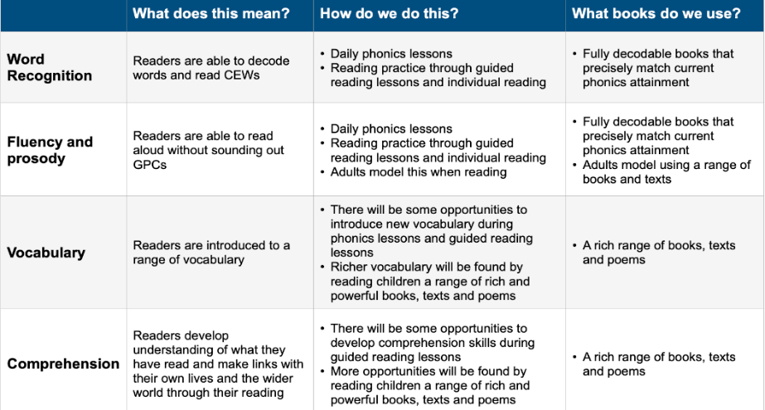
As well as the given decodable books encourage your child to read/ share a variety of fiction, non-fiction and poetry, including children’s newspapers, magazines, signs and displays.

ACCELERATED READER
We use a reading scheme called Accelerated Reader for Key Stage 2, and for some pupils in Year 2, once they have progressed through the phonetically decodable books.
As the children bring their reading books home you will notice a system of levelling books. The number on the front of the book indicates the reading level (which has been determined by the results of a reading assessment that all the children have completed). This enables us to have a much firmer understanding of the children’s progress. You will also hear about ‘quizzes’. This enables the monitoring of the children’s comprehension and whether they’ve understood their reading – not just read the words. Throughout the term, we will continue to celebrate and support the children with their reading habits and their comprehension skills.
Your child’s decimal reading range corresponds to books, which aim to challenge your child yet be decodable without your child getting frustrated or losing understanding. Teachers will adjust reading ranges at their discretion.
Children should aim to score at least 80% on a quiz in school to show that they have generally understood their reading text.
If your child is concerned that they are finding this tricky, they could try any of these:
- Choose a shorter book.
- Choose a book, which they prefer and find more engaging.
- Ask to read more of their text with an adult, who will help them to infer the meaning of new vocabulary and show them how to summarise whilst reading.

Homework in Gala
READING: The most important homework you can do is reading, as least 4 times a week. It is vital that this aspect of the homework routine is established quickly. Please record the pages/book read and sign in the reading record. Phonic books are changed on Monday Wednesday and Friday. Accelerated reader books will be changed by your child, as and when they complete a quiz. Your child will receive a merit if they have read at least 4 times a week.

PE Day
Gala class will have their PE lesson a Tuesday afternoon with Mrs Samuel and a Thursday morning with Mrs van Cole. If your child is unable to do PE for any reason, please can you provide a note/letter or phone the school office. Pupils should wear their school PE kits into school on a Tuesday and Thursday. Jewellery and watches should not be worn for PE lessons. As the term progresses and the weather gets colder, black tracksuit bottoms and the school jumper/P.E jumper can be worn for outdoor PE. We will be doing PE outside at least once a week, in all weather conditions.

Personal belongings
Please ensure that your child’s belongings are all labelled with their name. We supply all the stationery your child needs so a pencil case is not required. Children should not bring toys and cuddly toys or other precious items to school.

Water bottles & Snacks
It is proven that children learn best when they are hydrated, so we encourage children to bring in a labelled bottle containing water for the classroom, each day. Ideally, a sturdy, sports cap re-useable bottle works best. The children are able to refill these throughout the school day. Children are encouraged to bring their own fruit, vegetables or a sandwich in from home for a breaktime snack. Fruit will be provided for children in Gala class which they can help themselves to if they would like to.

Communication
Please email the school (office@curryrivel.somerset.sch.uk) and your message will be forwarded to us. You can also phone the school office to ask the class teacher to call you if you prefer.

