|  |  |
| --- | --- |
| Human vs Physical Geography | |
| Human  Houses  Roads  Bridges  Village  Factory  Port | Physical  Seas  Mountains  Rivers  Oceans  Trees  Wild flowers |

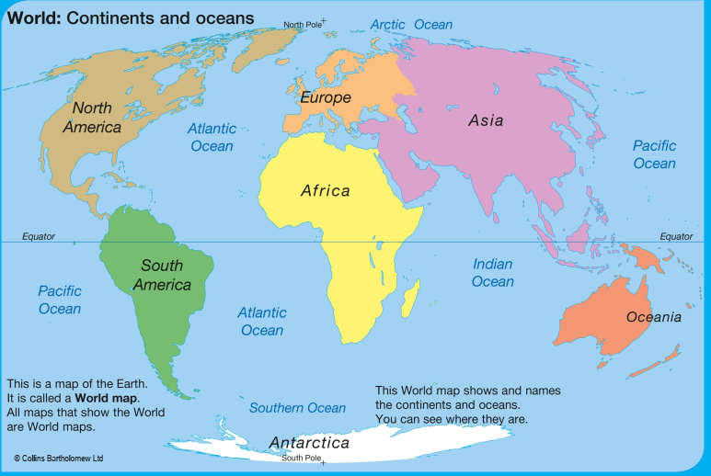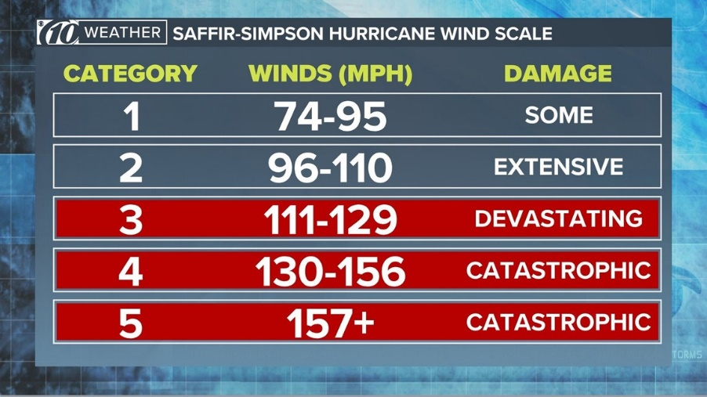 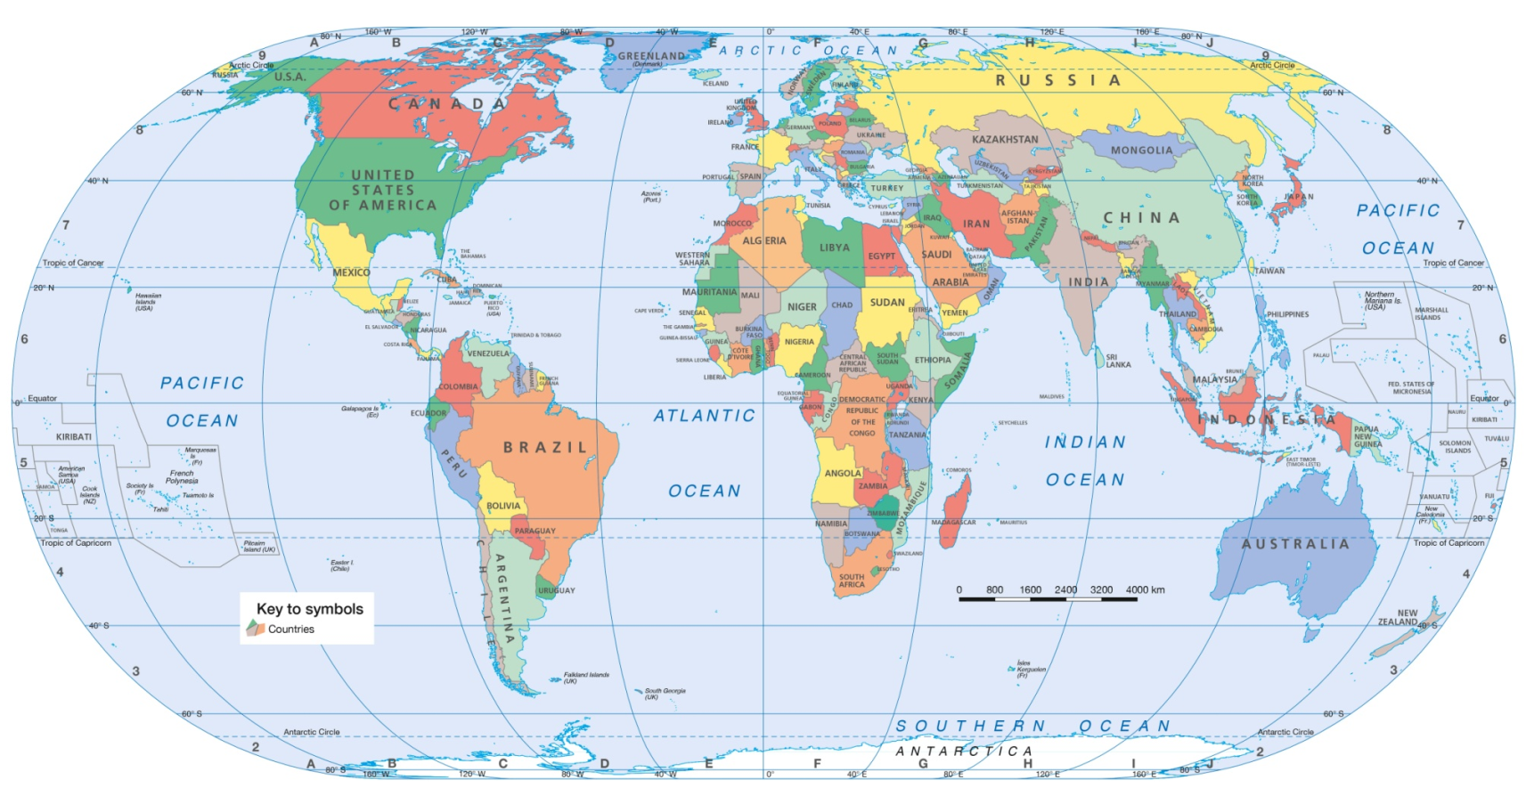

Geography Knowledge Organiser: Autumn 1

What is the Sunshine State really like?

KO: To gain an understanding of the physical and human geographical features of a region in North America in order to be able to compare and contrast the characteristics of the United Kingdom.