|  |  |  |
| --- | --- | --- |
| **Curry Rivel**  **Church of England**  **Primary School** | ***O:\New Logo and Web Images\JPEG\CR logo Purple +txt_renamed_32721.jpg***  ***‘Healthy Trees Bearing Good Fruit’*** | **Pippin Class**  **Spring newsletter**  **January 2025** |
| Dear Parents/Carers,  Welcome back and a very Happy New Year! We look forward to the spring term ahead. Now that the children have settled, this is the term I often find they flourish and mature into confident and curious learners. It is lovely to see, and I am looking forward to supporting them as they continue to immerse themselves in school life.  The children are very eager to continue using our outdoor area and mud kitchen. As the wet and cold weather continues, if your child wishes to bring in wellies or waterproofs, please ensure they are in a named bag. They can either leave them in school, or you may collect them when needed. (They will be stored in a trolley that can be put out at the end of the day.) This will support our outdoor learning during the next few months.  It is hoped that this newsletter gives you a flavour of what you can expect from the term ahead. Communication is so important, and although the beginning and end of the day do not allow for long conversations, you can always contact me via the school office or Tapestry. We also have parents’ evenings in the coming term, but please do not hesitate to contact the school if you feel there is anything that will help me support your child.  I feel it is important for you to have an understanding of what the school day looks like. Please see the timetable below, which illustrates a typical week in Pippin Class this term. This can be used to help you have conversations about what your child has been learning in school each day.  Best wishes,  Mrs Davies-Evans (Mon, Tue, Thu, Fri) and Miss Kilner (Wednesdays) | | |

|  |  |
| --- | --- |
| **SUPPORT TEAM**  C:\Users\ellie.martin\Downloads\ID badge.jpg  Mrs Myhill Miss Laurence Mrs Morrisroe Mrs Langford Mrs Monk   |  | | --- | | This is the team of adults who support Pippin class. Daily Mrs Myhill will be helping in Pippin class with Miss Laurence who is a 1.1 TA. On a Thursday Mrs Myhill will teach the class with support from Mrs Morrisroe so that Mrs Davies-Evans can have her planning time. The school ELSA (Emotional Literacy Support Assistant) is Mrs Langoford and Mrs Monk is the school SENDCo. | |

Please see below the curriculum overview to get an idea of what the spring term may look like.

Also attached is a planning document that outlines our learning for this half term, focusing on our topic, ‘Love is All We Need’, and how it links to each area of development in the Early Years Foundation Stage.

You will also find a knowledge organiser attached. This document includes key learning points that you can use to support your child at home. It will also provide suggestions for extra activities related to our topic.

|  |  |  |  |  |  |  |
| --- | --- | --- | --- | --- | --- | --- |
|  | English | Maths | DT/PSHE | RE | PE | Music |
| Spring 1 | Weirdo- Zadie Smith | Composition and comparison | Junk modelling | Special places | Gymnastics and Speed and Agility | Music and movement |
| Spring 2 | Ning and the Night Spirits -Adriena Fong  The Odd Egg Emily Grave | Health and well being | Time to celebrate | Cooperate and solve problems/ Body management |

**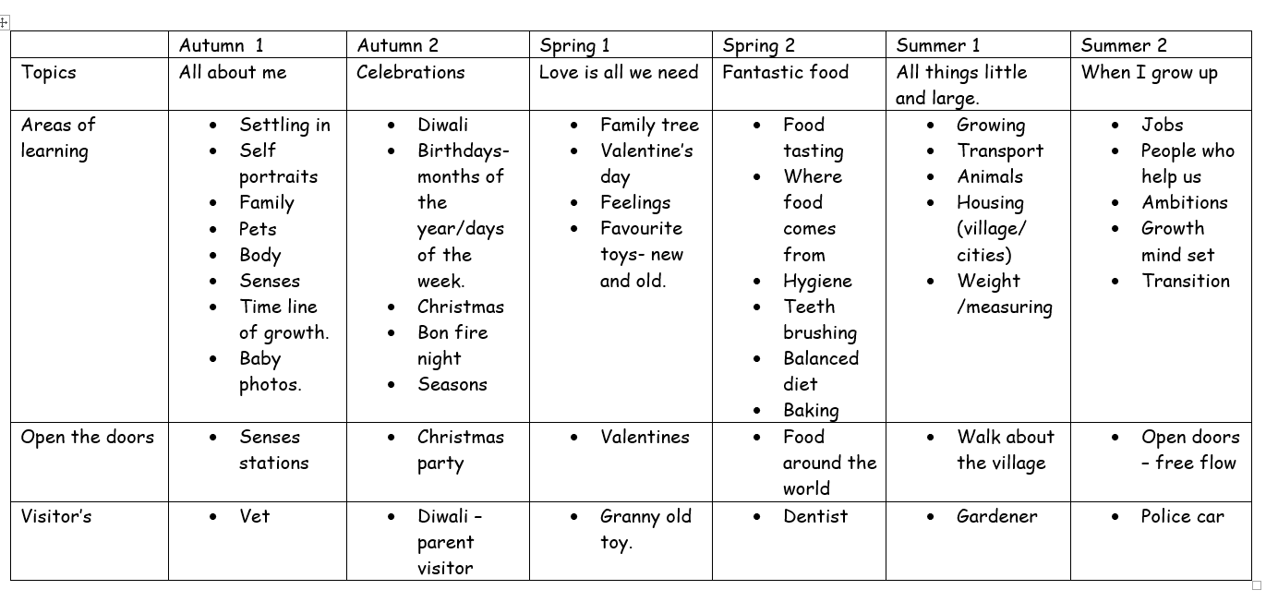**

**Supporting Reading at Home:**

Since last half term, you would have received a letter from me discussing the actions resulting from our audit with the English Hub. Please see below the changes in our expectations for reading at home.

Books that are sent home will match your child’s phonic ability. Your child should be able to read 95% of this book independently. The books will be fully decodable. If your child still has gaps within a phase of phonics, they may receive the same book more than once to practice the specific phonics knowledge they need. This is not based on a set book banding.

* **1, 2, 3 Read with Me Approach**: This is an approach to support you with structuring your reading sessions at home. Your child’s book will not be changed until it is demonstrated that your child has shared this book three times. Please record this in the book log.

Books will now be changed **twice weekly**—on **Mondays and Thursdays**. This allows for the 3-read guidance to be fulfilled.

Your child will bring home a **sharing book** every **Friday**. This is a book to share for pleasure, focusing on new vocabulary and storytelling. Please make sure this is returned weekly.

This term, in your child’s reading record, you will see some highlighted GPCs (Grapheme-Phoneme Correspondences) in the phonics section. The highlighted ones indicate the GPCs your child is not yet secure on. Please practice these at home by using flashcards and spotting them in words. Comment in the reading record on how your child is progressing, and we will continue to monitor and highlight their next area of need. Feel free to come and see me if you have any questions or would like support on how to deliver ongoing interventions in phonetic reading.

**Key Dates:**

* **11th February**: Open the doors for the children with Little Pips Valentine's provision.
* **13th February**: Parents' sharing morning.

|  |
| --- |
| **PE**  Pippin class will have their PE lesson on **Wednesday** and **Thursday** mornings  If your child is unable to do PE for any reason, please can you provide a note/letter or phone the school office. Pupils should wear their school PE kits into school on a Monday and Thursday. Jewelry and watches should not be worn for PE lessons. As the term progresses and the weather gets colder, black tracksuit bottoms and the school jumper/cardigan can be worn for outdoor PE. |

|  |
| --- |
| **Water bottles & Snacks**  It is proven that children learn best when they are hydrated, so we encourage children to bring in a labelled bottle containing water for the classroom, each day. Ideally, a sturdy, sports cap re-useable bottle works best. The children are able to refill these throughout the school day. Fruit will be provided for children in Pippin class or children can bring their own fruit in from home for break. This is a fruit or vegetable snack only. |

|  |
| --- |
| **Personal belongings**  Please ensure that your child’s belongings are all labelled with their name. We supply all the stationery your child needs so a pencil case is not required. Children should not bring toys and cuddly toys or other precious items to school. |

|  |
| --- |
| **Homework in Pippin Class**.  **READING**: The most important homework you can do is reading, as least 3 times a week for 10 minutes a day. It is vital that this aspect of the homework routine is established quickly. Please record the pages/book read and sign in the reading record. Phonic books are changed on Monday and Thursday and the reading record is also checked on these days. Your child will receive a merit if they have read 3 times a week. |

|  |
| --- |
| **Communication**  Please email the school (office@curryrivel.somerset.sch.uk) and your message will be forwarded to me. Or contact me via tapestry. You can also phone the school office to ask the class teacher to call you if you prefer. |