Teaching Team
Pippin Class: Reception | Maigold Class: Years 1/2 | Gala Class: Year 2/3
 |  | 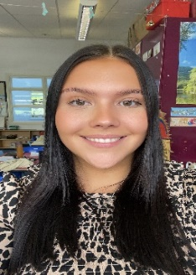
Mrs Zoe Davies Evans Miss Ashleigh Carnie Miss Ellie Martin
Discovery Class: Year 4  Mr Jack Bridgeman | Camelot Class: Year 5  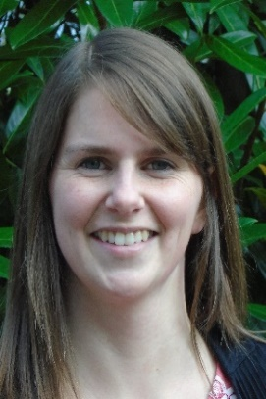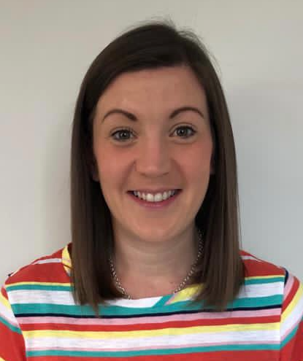  Mrs Sarah Samuel &  Mrs Hannah van Cole | Blenheim Class: Year 6  Miss Fay Tucker

