Key vocabulary
Season | The year is split into four parts according to the climate.
Weather | The condition outside in a particular time or place.
Climate | The usual weather conditions in place.
Equator | The imaginary circle around the earth that is halfway between the North and South Poles.
Temperate | Having neither very hot nor very cold temperatures. They have typically mild weather.
Country | A large area of land where people live under the same government.
Continent | One of the earth's seven major areas of land. The continents are Africa, Antarctica, Asia, Australia Europe, North America, and South America.
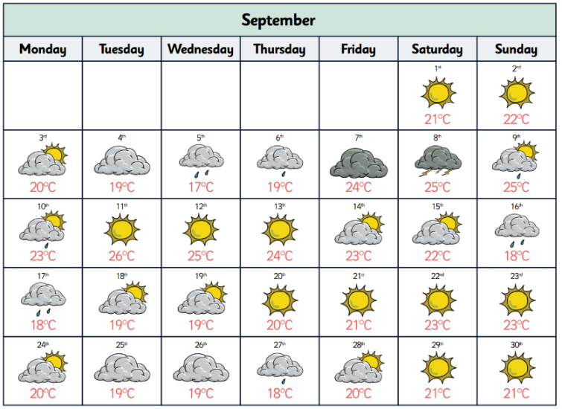
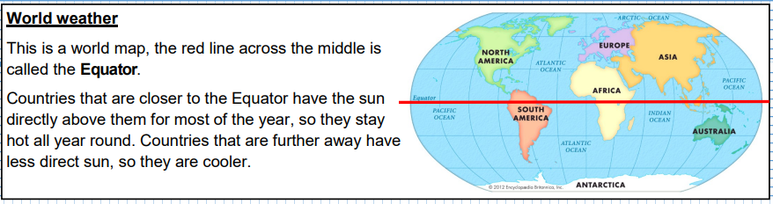
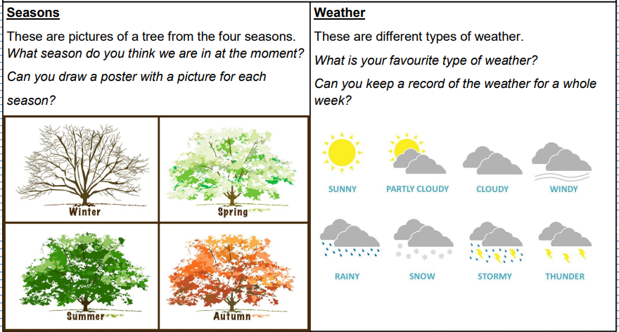
Weather can be recorded and analysed through the use of a weather map.

