Curry Rivel  Church of England  Primary School | 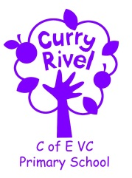  ‘Caring, curious and confident’ | Discovery Class  Autumn Newsletter  September 2021
Dear Parents/Carers,

Welcome to Discovery Class and the new school year. It is exciting to be back to school in our new class. We hope you have had a good rest and some quality time with your child/ren.

It is hoped that this newsletter gives you a flavour of what you can expect from the term ahead. Communication is so important, and although the beginning/end of the day does not allow for long conversations, you can always contact us via the school office. We also have parents’ evening before the half term break.

It is important that you have an understanding of what the school day looks like. Please see the timetable below which illustrates a typical week in Discovery Class this term- this can be used to help you have conversations about what your child has been learning in school each day.
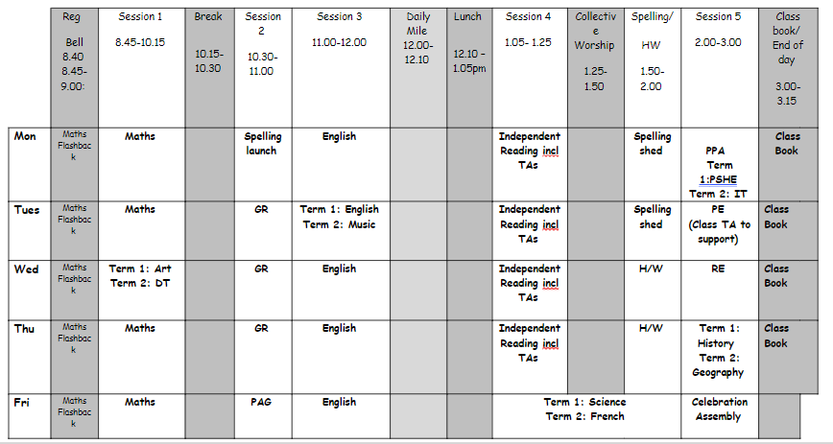
We look forward to working in partnership with you to help your child develop and grow as a learner and as a person.

Mrs Hardwick & Mrs van Cole



SUPPORT TEAM
It is always good to know which other adults are supporting our class, so here is the support team:

Mrs Ainsworth is our class Teaching Assistant
Mrs Ward is the school SENDCo
Mrs Langford is the school ELSA (Emotional Literacy Support Assistant) teaching across the school.
Mrs Langford / Mrs Slade will be teaching PSHE / ICT to the class during teacher planning time on Monday afternoons.

Our Ambitious Curriculum at Curry Rivel Church of England Primary School

We aim for all our pupils to be ‘Caring, Curious and Confident’ learners. Our curriculum is a ‘knowledge-rich’ and ‘sticky’ curriculum, based on the teaching of core concepts and skills.
What is a KNOWLEDGE-RICH APPROACH?

‘The accumulated wealth of human knowledge, and what we choose to pass on to the next generation through teaching in our schools (the curriculum), must be at the heart of education’ (Amanda Spielman).
Knowledge underpins and enables the application of skills. We strive for children to learn skills alongside knowledge, ensuring that both are developed. At Curry Rivel Church of England Primary School and Little Pips Nursery we see knowledge and skills as intertwined. We believe that this is important for making the curriculum relevant and meaningful to pupils and for putting knowledge into context.
We have looked at every curriculum area individually, as we recognise that each subject is unique and includes its own substantive knowledge, disciplinary knowledge and skills. We have sequenced the content of many of our subjects using ‘rolling programmes’ which ensure that whatever path a pupil takes through the school, the National Curriculum content is covered. More importantly, our curriculum is a ‘spiral curriculum’ in which key concepts are presented repeatedly throughout the curriculum, but with deepening layers of complexity.
In Discovery Class this term, we will be studying the following units of work:
English | Own Historical narratives, Mystery Narratives, Newspaper Reports, Non-Chronological Reports |  | Science | Animals including humans
Maths | Place Value, Addition and Subtraction |  | Computing | “I am kind and responsible”  E-Safety, Class internet rules, cyber bullying.
PE | Gymnastics & Hockey |  | Design Technology | Structures - Pavillions
Music | Listening and appraising the song “Three Little Birds” by Bob Marley and other related songs. |  | Personal Social Health Economic Education (PSHE) | ‘Health & Wellbeing’ including diet and dental hygiene, celebrating mistakes, emotions and mental health.
RE | Christianity - Agape |  | History | Stone Age to Iron Age
French | Greetings
Knowledge Organisers for Maths, Science, History and Geography will be sent home. These can be used to discuss what your child is learning in school; you can use a knowledge organiser in different ways: Read through it together; discuss tricky vocabulary; quiz your child on the knowledge they have acquired; play true and false games with the facts.
PROMOTING READING
A good ability in reading is fundamental to everything that the children will learn in class during the year, and regular practice is therefore the most important aspect of homework that he or she will have. Please keep in touch with us if you are experiencing difficulties with helping your child with this vital regular activity. For our part, we will let you know if there is insufficient reading practice taking place. (Daily home reading is expected as least 4 times a week). Here are some top tips:
- All children need to read some of their book aloud to you whatever their ability
- Agree daily targets with your child. E.g. 10 pages or 20 minutes
- Discuss what your child is reading
- Read to your child regularly: this could be a book you have chosen together or could be your child’s school book.
- Record all home reading in the reading diary.

ACCELERATED READER

We use a reading scheme called Accelerated Reader for Key Stage 2, and for some pupils in Year 2. As the children bring their reading books home you will notice a system of levelling books. The number on the front of the book indicates the reading level (which has been determined by the results of a reading assessment that all the children have completed). This enables us to have a much firmer understanding of the children’s progress. You will also hear about ‘quizzes’. This enables the testing of the children’s comprehension and whether they’ve understood the book. Throughout the term we will able to monitor the children’s reading habits and their comprehension skills, and can adjust their levels as they improve.
Handwriting Leagues
Children in all year groups have the chance to have a handwriting pen if they reach ‘Black-belt Ninja’ level in our handwriting leagues. Children need to join their writing neatly, with consistent and correct joins and sizing. Pens will be awarded when this level is achieved and can be withdrawn if standards slip.

Homework in Year 3 & Year 4
The most important homework you can do is reading, as least 4 times a week. It is vital that this aspect of the homework routine is established quickly. All other homework is set on Google Classroom. More information on this will follow.

PE Day: Tuesdays
If your child is unable to do PE for any reason, please can you provide a note/letter or phone the school office. Pupils should wear their school PE kits into school on those days. School sweatshirts/cardigans please (No sports hoodies or sports tops please). Jewellery and watches should not be worn for PE lessons. As the term progresses and the weather gets colder, black/navy tracksuit bottoms can be worn for outdoor PE. Please bare this in mind, as we will be doing PE outside at least once a week, on top of the daily mile, in all weather conditions.

Water bottles & Snacks
It is proven that children learn best when they are hydrated, so we encourage children to bring in a labelled bottle containing water for the classroom, each day. Ideally, a sturdy, sports cap re-useable bottle works best. The children are able to refill these throughout the school day. Children are encouraged to bring fruit, vegetables or a sandwich for a breaktime snack.

Personal belongings
Please ensure that your child’s belongings are all labelled with their name. We supply all the stationery your child needs so a pencil case is not required. Children should not bring toys and cuddly toys or other precious items to school.

Communication
Please email the school (curryrivelprimary@educ.somerset.gov.uk ) and your message will be forwarded to me. You can also phone the school office to ask the class teacher to call you if you prefer. We appreciate that there is a wonderful family atmosphere here, and not being able to linger for chats is hard. You have been very complimentary about how we have kept you informed over the past year- continuing this will be vital. We will be organising a parents’ evening before half term.

