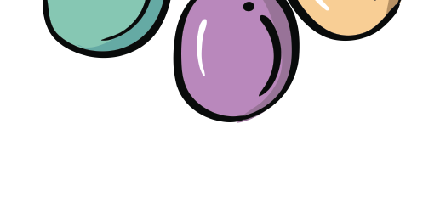
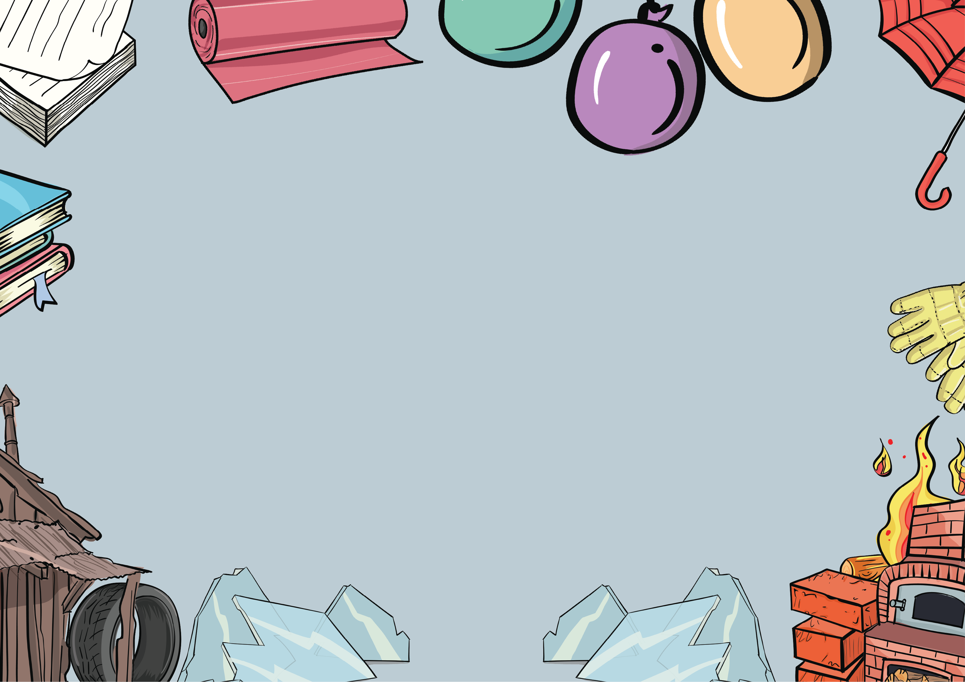
Materials Knowledge Organiser

All of these materials are fantastic. They are each perfectly suited to make certain objects.
Depending on the task, some materials are better suited than others.

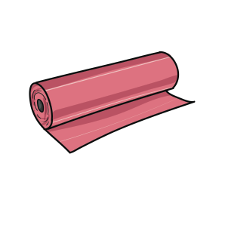
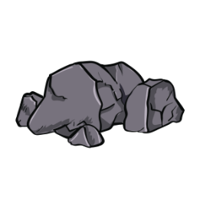
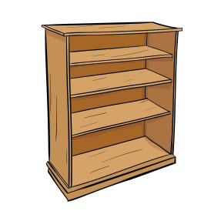
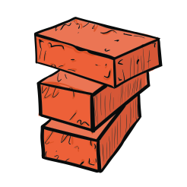

rock fabric paper brick wood
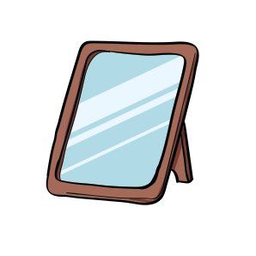

rubber glass plastic metal

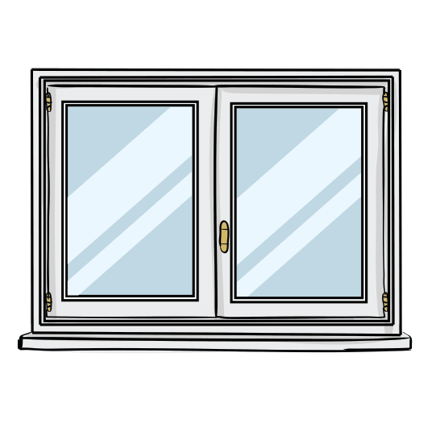

This is a window. Windows are made from glass. Glass is see-through which makes it a good material for the window as it lets light into your house and allows you to see out. The glass also stops rain and wind entering your house.

This is a pair of wellington boots. They are made from rubber.
Rubber is strong, waterproof and bendy which makes it a good material for wellies. They will be comfy on your feet, keep your feet dry and not damage easily.

www.grammarsaurus.co.uk

Changing the shape of materials Key Vocabulary

We can change the shape of some objects by —

squashing them bending them twisting them
and stretching them.

It is useful to be able to change the shape of some materials.

Fabric needs to be stretchy so that clothes fit our bodies. Imagine if socks weren’t stretchy!

Some materials cannot be changed which is also useful.

Brick needs to be strong and firm. Imagine if bricks for houses were bendy!
brick - a hard, strong and rough material used to build houses

fabric - a soft material used to make clothes

glass - a hard but fragile material that is usually transparent and is used to make windows

material - the matter from which an object is made

metal - a material used to make cars, cutlery and some musical instruments; it is usually strong, hard and shiny

paper - a material that can easily tear used to make books and wrapping paper
plastic - a material used to make bottles, toys and food packaging; it can be strong, but some plastics can
also be squashed

properties - a characteristic of something

rock - a strong and hard material used to make roof tiles

rubber - a bendy material used to make car tyres and wellington boots

wood - a material made from trees that is used to make furniture

www.grammarsaurus.co.uk

