|  |  |  |  |  |  |
| --- | --- | --- | --- | --- | --- |
| Communication and Language | | Personal, Social and Emotional Development | | Physical Development | |
| -Family tree who’s in my family circle time  - Pets pictures  - Class room friends guess who, asking questions of others.  -Senses, likes and dislikes. | | -Valuable self, people close to us, cultures and family.  - I like to – children to perform own talent show  -Bring in and celebrate own outside achievements.  -The human body create junk modelling robots discussing how to look after them. – Hygiene and food. | | -My body- gross motor skills. Learning about parts of the body.  - Calm and reflective time, to think about achievements of the day.  -Being safe, using tools such as scissors carefully.  - Team building games- e.g cross the river helping each other across. | |
| All About Me | | | | | |
| Literacy | Mathematics | | Understanding the World | | Expressive Arts and Design |
| -Doh disco- making a face out of playdoh.  -Mark making, my family  -Listen to stories and comment on how every family is different.  -segmenting actions to complete senses surprise box. | * Using shapes to create the human body. * Measuring using cubes, feet size and leg/ Arm lengths. * Sharing quantities between friends. * Subsidising family members. | | * When I grow up discussing timeline of growth. Baby till now discussing the past * Family photos. * Discuss feelings and experiences of showing kindness, bravery etc. * Senses outside our local environment and place we live. | | Draw Self-portraits using mirrors.  Feel good through music.  Talents and self confidence in performing  Role play home corner. |

Wee

Autumn 1 phonics progression:

Phase2: s,a,t,p,i,n,m,d,g,o,c,k,ck,e,u,r,h,b,f,ff,l,ll,ss

Words ending in s

Tricky words : the, to,into,no, I ,go.

Open the doors

Senses stations

With Little Pips.

WC 14.10.2024

RE: Special me and Special times. PHSE: Online safety

Music: Exploring Sound Computing: BAREFOOT- Busybodies

English key texts:

Hairy Maclary from Donaldson’s Dairy- Lynley Dodd

Bringing the Rain to Kapiti Plain- Verma Aardema

NCETM Maths:

Number blocks

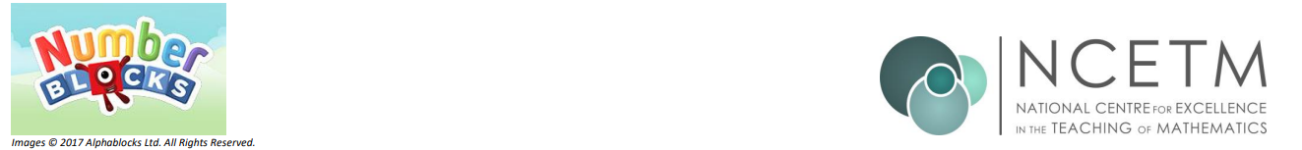

* Replace title (keep title and footer pink)
* Change images to pngs relevant to new topic
* Keep the headers and colours as they are (they use the EYFS specific colours for the areas of learning)
* Replace bullet points with text from teacher content. Hyperlinks within the bullet points should be bold, blue and underlined.
* Try to keep content to 1 page (ask Lucy if unsure to do this)
* Delete this instructions box