Curry Rivel  Church of England  Primary School | 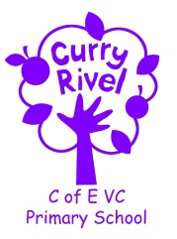  ‘Healthy Trees Bearing Good Fruit’ | Maigold Class  Spring newsletter  January 2024
Dear parents/carers,

Welcome back! We hope you have had the opportunity to enjoy some time together this Christmas and we wish you a happy New Year. We are excited for the new Spring Term and cannot wait to get started with our learning.
It is hoped that this newsletter gives you a flavour of what you can expect from the term ahead. Communication is so important, and although the beginning/end of the day does not allow for long conversations, you can always contact us via the school office.
It is important that you have an understanding of what the school day looks like. Please see the timetable below, which illustrates a typical week in Maigold Class this term. This can be used to help you have conversations about what your child has been learning in school each day.

Best wishes,

Miss Carnie

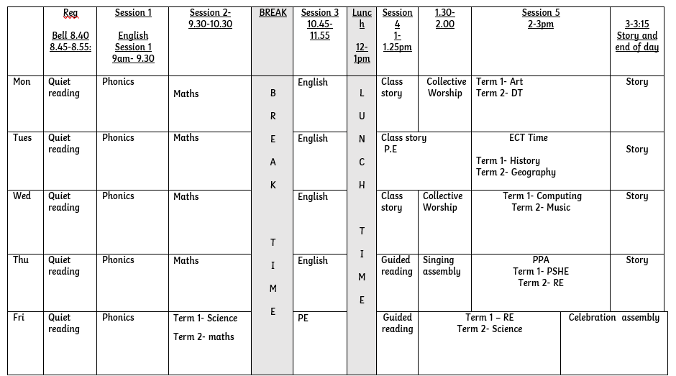

SUPPORT TEAM
It is always good to know which adults are working with and supporting our class, so here is the Maigold team:

Mrs Taylor is Maigold’s Teaching Assistant.
Miss Kilner will teach Maigold on a Tuesday afternoon to allow Miss Carnie to complete early career teacher training.
Mrs Langford is the school Emotional Literacy Support Assistant (ELSA).

In Maigold Class this term, we will be studying the following units of work:
English  Protection and conservation  Doing the right thing | Spring 1-  - Send for a superhero  - We are water protectors.  Spring 2-  - Tadpoles promise  - Dinosaurs and all that rubbish/ |  | Science | In science, we will be learning about every day materials.
Maths year 1 | - Shape  - Numbers 0-10  - Additive structure  - Addition and subtraction facts within 10. |  | Maths year 2 | - Multiplication  - Division  - Shape  - Addition and subtraction of 2 digit numbers.
PE | Spring 1:  Tuesday- Outdoor Adventurous Activities (OAA).  Friday- Send and return  Spring 2:  Tuesday- Circuits  Friday- Attack, defend, shoot. |  | Design Technology | In DT, we will be making and designing pouches. They will use and develop their sewing skills to be able to sew a running stitch.
Music | In music, we will be looking at ‘inventing a musical story’. This will focus on expressing our feelings through a musical story. |  | PHSE | In PSHE, we will be learning about ‘responsibility, community and democracy’.
RE | ‘What do candles mean to people?’. |  | Geography | In Geography, we will be focusing on ‘Why does it matter where our food comes from?’.
Phonics | Phase 5 learning |  | History | In history, the children will be learning about ‘famous explorers’ and what makes a good explorer.
Art | In art, our unit will be ‘drawing- making your mark. In this unit, they will explore their own ideas using a range of media. |  | Computing | In computing, we will be focusing on digital painting using ipads.
Supporting reading at home:
Daily home reading is expected as least 4 times a week. Reading records and books will be monitored/changed 3 times a week. Monday, Wednesday and Friday. Books will be changed if your child has finished their book and read it more than once. Please sign or initial and record any comments or unfamiliar vocabulary, which will help school to build on the reading you are doing at home. If your child does not read at least 4 times over the week, the children will read during Friday lunchtime and an adult will listen to them read to support their reading development. Please do not hesitate if you need support with assisting reading at home.
In order for children to become confident, fluent and enthusiastic readers, it is essential that we teach and give them opportunities to develop all of these skills.
For our early readers, this will mean using different books in different ways:
You can focus your 4 reads a week on these skills.
1. Child to use word recognition, segmenting and blending the text to read aloud.
2. Fluency and prosody- Child and adult reads modelling fluency and expression using a storyteller voice.
3. Adult/child to read together discussing vocabulary throughout.
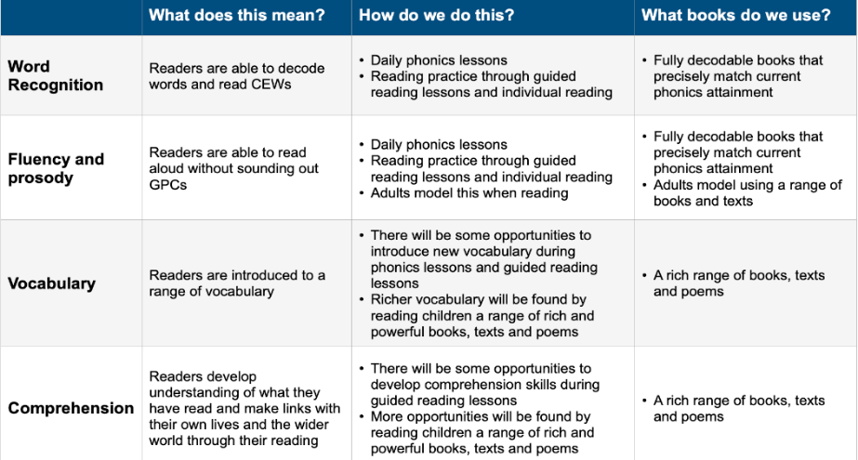
4. Child to re-read the book making sense of what has been read.
As well as the given decodable books encourage your child to read/ share a variety of fiction, non-fiction and poetry, including children’s newspapers, magazines, signs and displays.

ACCELERATED READER
We use a reading scheme called Accelerated Reader for Key Stage 2, and for some pupils in Year 2, once they have progressed through the phonetically decodable books.
As the children bring their reading books home you will notice a system of levelling books. The number on the front of the book indicates the reading level (which has been determined by the results of a reading assessment that all the children have completed). This enables us to have a much firmer understanding of the children’s progress. You will also hear about ‘quizzes’. This enables the monitoring of the children’s comprehension and whether they’ve understood their reading – not just read the words. Throughout the term, we will continue to celebrate and support the children with their reading habits and their comprehension skills.
Your child’s decimal reading range corresponds to books, which aim to challenge your child yet be decodable without your child getting frustrated or losing understanding. Teachers will adjust reading ranges at their discretion.
Children should aim to score at least 80% on a quiz in school to show that they have generally understood their reading text.
If your child is concerned that they are finding this tricky, they could try any of these:
- Choose a shorter book.
- Choose a book, which they prefer and find more engaging.
- Ask to read more of their text with an adult, who will help them to infer the meaning of new vocabulary and show them how to summarise whilst reading.

PE
Maigold class will have their PE lesson a Tuesday afternoon with Miss Kilner and a Friday morning with Miss Carnie.
If your child is unable to do PE for any reason, please can you provide a note/letter or phone the school office. Pupils should wear their school PE kits into school on a Friday. Jewellery and watches should not be worn for PE lessons. As the term progresses and the weather gets colder, black tracksuit bottoms and the school jumper/cardigan can be worn for outdoor PE. We will be doing PE outside at least once a week, on top of the daily mile, in all weather conditions.

Water bottles & Snacks
It is proven that children learn best when they are hydrated, so we encourage children to bring in a labelled bottle containing water for the classroom, each day. Ideally, a sturdy, sports cap re-useable bottle works best. The children are able to refill these throughout the school day. Fruit will be provided for children in Maigold class or children can bring their own fruit in from home for break.

Personal belongings
Please ensure that your child’s belongings are all labelled with their name. We supply all the stationery your child needs so a pencil case is not required. Children should not bring toys and cuddly toys or other precious items to school.

Homework in Maigold Class.
READING: The most important homework you can do is reading, as least 4 times a week. It is vital that this aspect of the homework routine is established quickly. Please record the pages/book read and sign in the yellow reading record. Phonic books are changed on Monday Wednesday and Friday and the reading record is also checked on these days. Your child will receive a merit if they have read at least 4 times a week and 2 merits if they have read more than 4 times.

Communication
Please email the school (office@curryrivel.somerset.sch.uk) and your message will be forwarded to me. You can also phone the school office to ask the class teacher to call you if you prefer.

