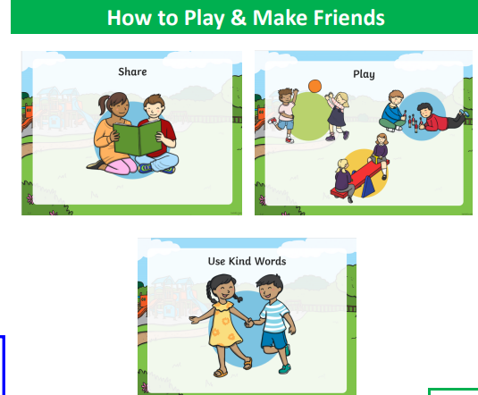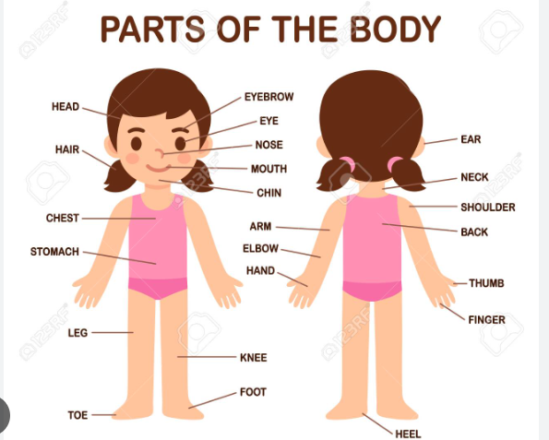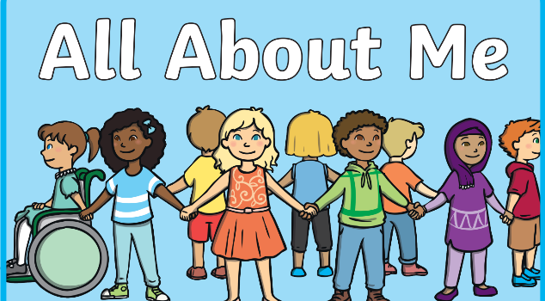Our five senses are:

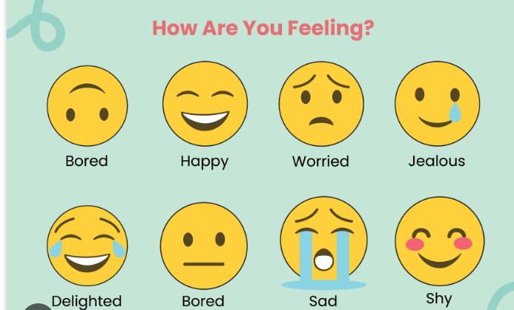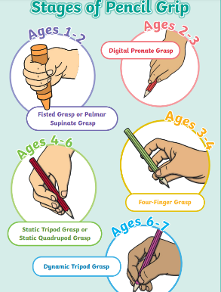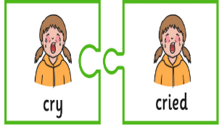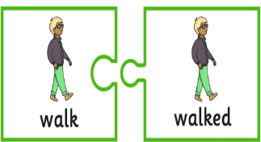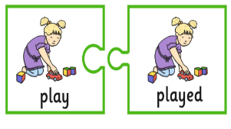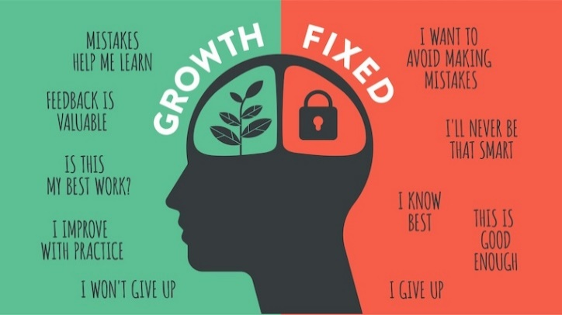

**Key vocabulary.**

Relatives: A person connected by blood or marriage

Respect: To take into consideration someone’s feelings and to care for all resources.

Listen: to look and pay attention to others

Share: To take turns and speak and listen to others.

Activities to support learning.

Upload to tapestry or

Bring in your creations.

* Create a family tree.
* Practice making your feeling faces in the mirror discussing when you may have experienced that feeling.
* Practise using past and present tenses.
* Draw a face practising circles.
* Shout three things you have done well or want to keep trying before bed to practice your growth mind-set.

- Upload a picture of your pets to tapestry.

Past tenses