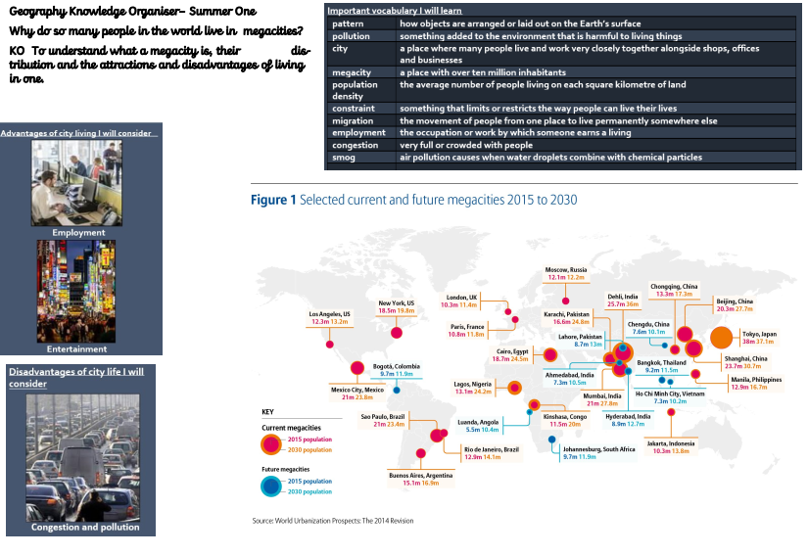

Geography Knowledge Organiser – Summer 2

Why do so many people in the world live in megacities?

We will; understand what a megacity is, their distribution and the advantages and disadvantages of living in one.