Kitchen and Lunchtime Team

 | 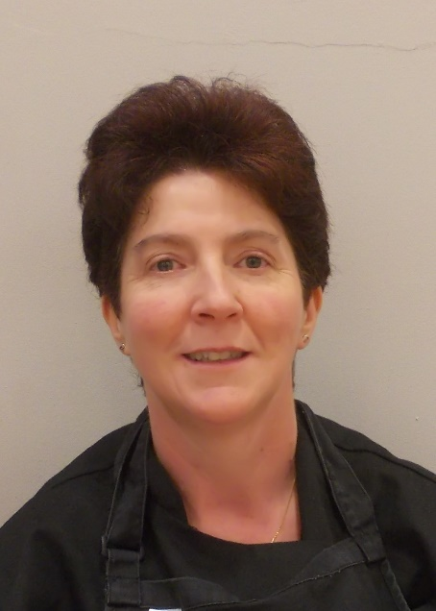 | 
Mrs Louise Dance  Kitchen Manager | Mrs Debbie Elliot  Kitchen Assistant | Mrs Shirley Larcombe  Lunchtime Supervisor

