Apple Trees Wraparound Care Team
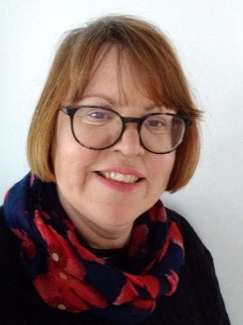 | 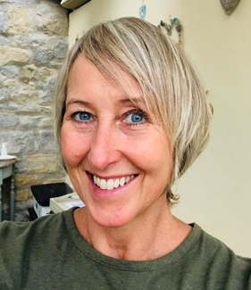 | 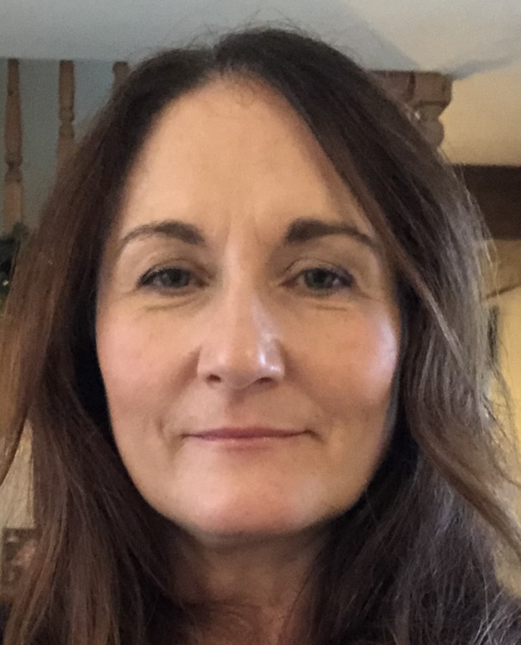
Mrs Jane Snow  Apple Trees Superviser | Mrs Paula Griffin  Assistant | Mrs Georgina Morrisroe  Assistant
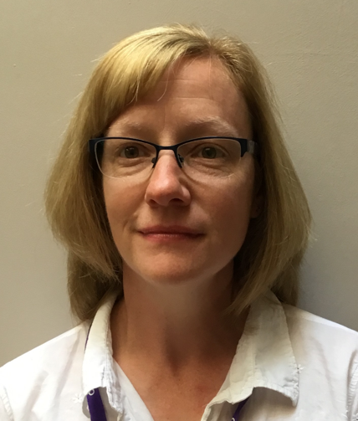 | 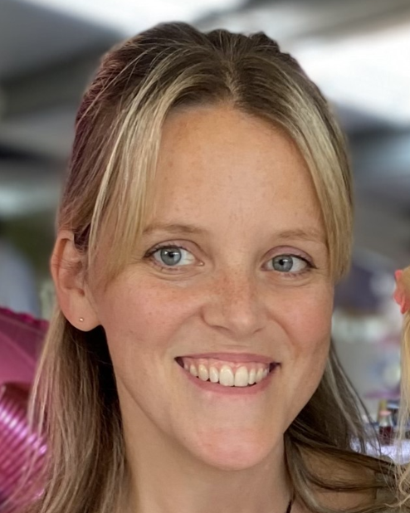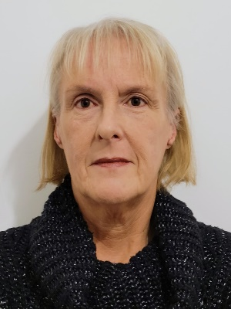 | 
Mrs Emma Myhill  Assistant | Mrs Ele Cerri Mrs Dee Long  Assistant Assistant | Miss Elle Andrews  Assistant

