|  |  |  |  |  |  |
| --- | --- | --- | --- | --- | --- |
| Communication and Language | | Personal, Social and Emotional Development | | Physical Development | |
| - To ask questions of what happened in past events- e.g Christmas story/Guy Fawkes.  - Using connectives to speak about celebrations  - To use speech to solve problems- e.g present surprise box  “I think it could be,  - Acting out a key story/event  -listen/sing Christmas songs/rhymes. | | -Complements of others work to celebrate achievements.  - tell others about family’s celebrations  -Talk about the perspective of others in a story- Remembrance Day. | | -Movement to how we feel.  -use scissors to cut out shapes for Christmas  -building a grotto  -I can write my name in Christmas cards  -I know why sleep is important | |
|  | | | | | |
| Literacy | Mathematics | | Understanding the World | | Expressive Arts and Design |
| -Doh disco to Christmas songs making own actions  -Mark make – fireworks following instructions in where to start letters.  -Capital letters for names Christmas party invites. | * Using shapes to create the festive objects. * Count 10 objects to decorate a tree * Dice rolling movement dancing to music. * Count in 10’s for fireworks to go bang. * Length – present ordering | | * Family photos- looking at own celebrations- past and present * Senses outside our local environment and place we live- looking at seasonal changes. * Celebrations of others – Diwali- questions and places of worship. * Write Christmas cards for staff members saying thank you. * Where I live and where Santa will visit. | | Create team art work- wreaths  Nativity performance sing and dance in tune and in sequence.  Watch a show and discuss it. |

Vut out  
Wee

Autumn 2 phonics progression:

Phase3 j,v,w,x,y,z,zz,qu,ch,sh,th,ng,ai,ee,igh,oa,oo,ar,or,ur

Words ending in ing

Trickywords: : go,me,we,be,he,she,was,you,they and all.

Open the doors

Christmas Party

19-12-24

RE: Nativity PHSE: Self image Music: Nativity

English key texts:

Hallibut Jackson

Oi Frog

NCETM Maths:

Number blocks

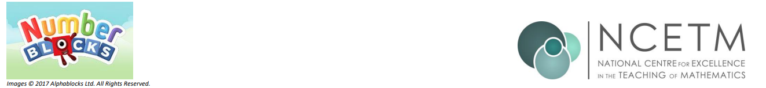

* Replace title (keep title and footer pink)
* Change images to pngs relevant to new topic
* Keep the headers and colours as they are (they use the EYFS specific colours for the areas of learning)
* Replace bullet points with text from teacher content. Hyperlinks within the bullet points should be bold, blue and underlined.
* Try to keep content to 1 page (ask Lucy if unsure to do this)
* Delete this instructions box